**Assignment 1:**

**Q1:**

Convert the following pseudocode to C++ code. Be sure to define the appropriate variables.

Store 20 in the *speed* variable.

Store 10 in the *time* variable.

Multiply *speed* by time and store the result in the *distance* variable.

Display the contents of the *distance* variable.

**Code:**

1. #include <iostream>
3. using namespace std;
5. int main()
6. {
7. const int speed = 20;
8. const int time = 10;
10. int distance;
12. distance = speed * time;
14. cout << "The distance is " << distance << endl;
16. return 0;
17. }

**Output Window:**

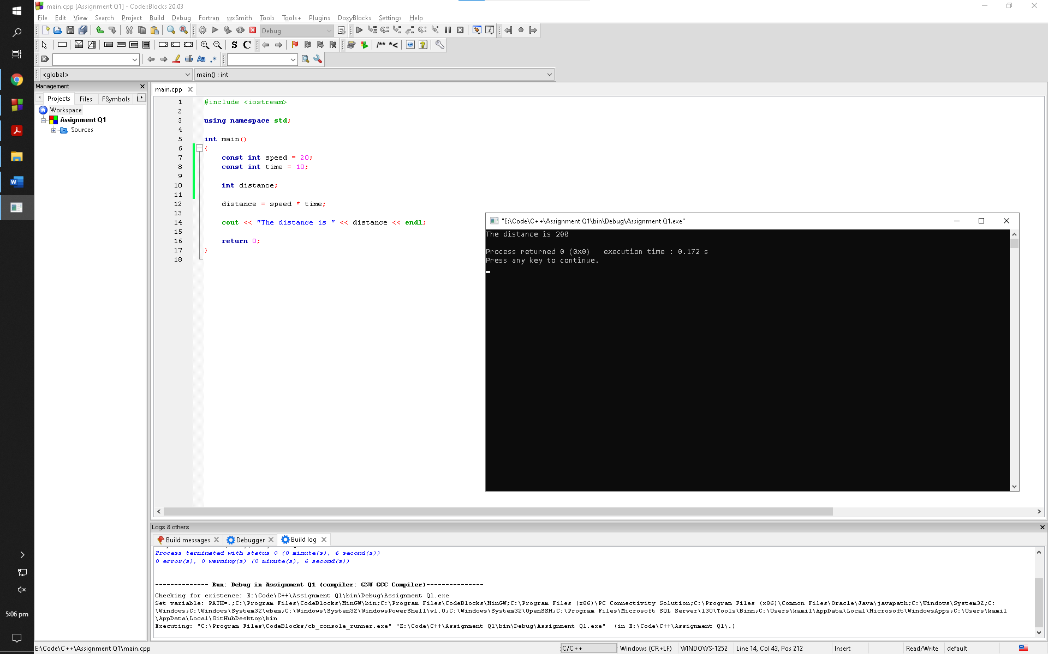

**Q2:**

The East Coast sales division of a company generates 62 percent of total sales. Based on that percentage, write a program that will predict how much the East Coast division will generate if the company has $4.6 million in sales this year.

**Code:**

1. #include <iostream>
3. using namespace std;
5. int main()
6. {
7. const float percent = 0.62;
9. float revenue, sales;
11. cout << "Enter your revenue in millions: ";
12. cin >> revenue;
14. sales = revenue * percent;
16. cout << "Total sales revenue for this year is " << sales << " millions" << endl;
18. return 0;
19. }

**Output Window:**

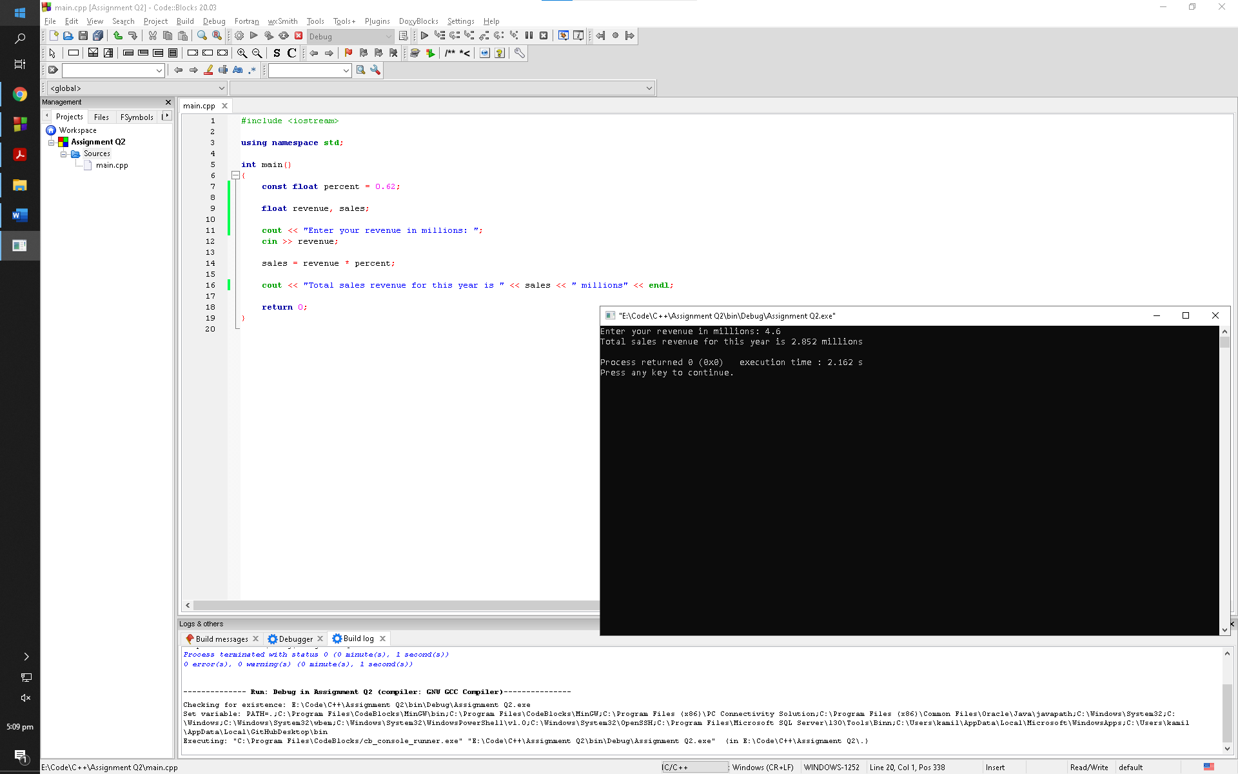

**Q3:**

Write a program that computes the tax and tip on a restaurant bill for a patron with a $44.50 meal charge. The tax should be 6.75 percent of the meal cost. The tip should be 15 percent of the total after adding the tax. Display the meal cost, tax amount, tip amount, and total bill on the screen.

**Code:**

1. #include <iostream>
2. #include <iomanip>
4. using namespace std;
6. int main()
7. {
8. const float taxP = 0.0675;
9. const float tipP = 0.15;
11. float charge, tax, afterTax, yourTip;
13. cout << "Input your meal charges: ";
14. cin >> charge;
16. tax = charge * taxP;
17. afterTax = charge + tax;
18. yourTip = afterTax * tipP;
20. cout << setprecision(2) << fixed << endl;
22. cout << "Your meal charges are $" << charge << endl;
23. cout << "Your tax is $" << tax << endl;
24. cout << "Your tip is $" << yourTip << endl;
26. return 0;
27. }

**Output Window:**

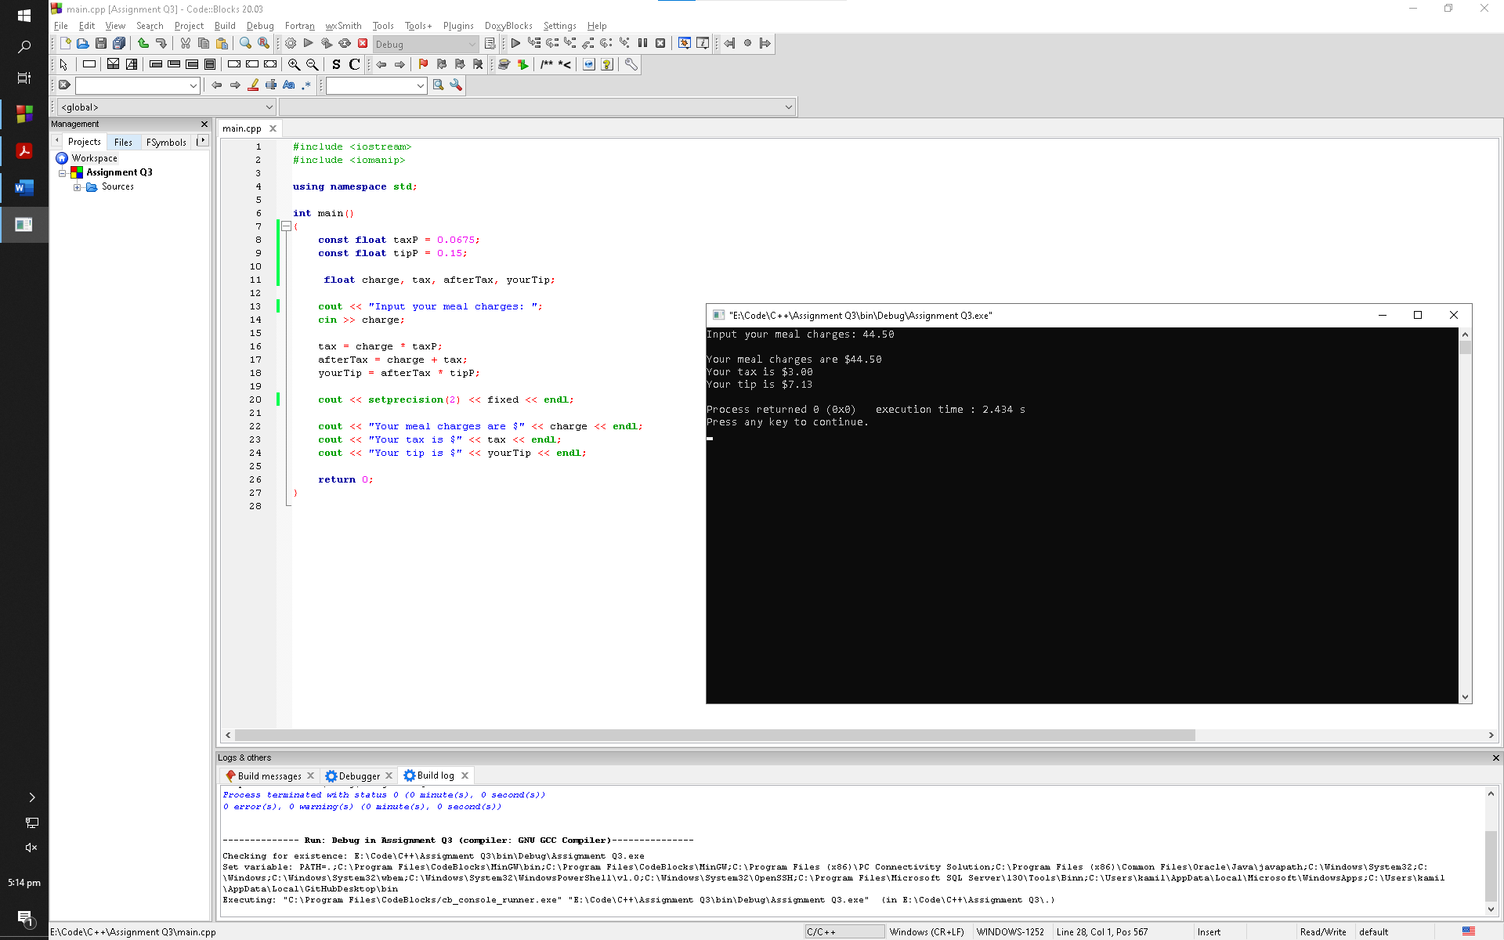

**Q4:**

Suppose an employee gets paid every two weeks and earns $1700.00 each pay period. In a year the employee gets paid 26 times. Write a program that defines the following variables:

**payAmount:** This variable will hold the amount of pay the employee earns each pay period. Initialize the variable with 1700.0.

**payPeriods:** This variable will hold the number of pay periods in a year. Initialize the variable with 26.

**annualPay:** This variable will hold the employee’s total annual pay, which will be calculated.

The program should calculate the employee’s total annual pay by multiplying the employee’s pay amount by the number of pay periods in a year, and store the result in the annualPay variable. Display the total annual pay on the screen.

**Code:**

1. #include <iostream>
3. using namespace std;
5. int main()
6. {
7. const float payAmount = 1700.0;
8. const float payPeriods = 26;
10. float annualPay;
12. annualPay = payAmount * payPeriods;
14. cout << "The annual pay for the employee is $" << annualPay << endl;
16. return 0;
17. }

**Output Window:**

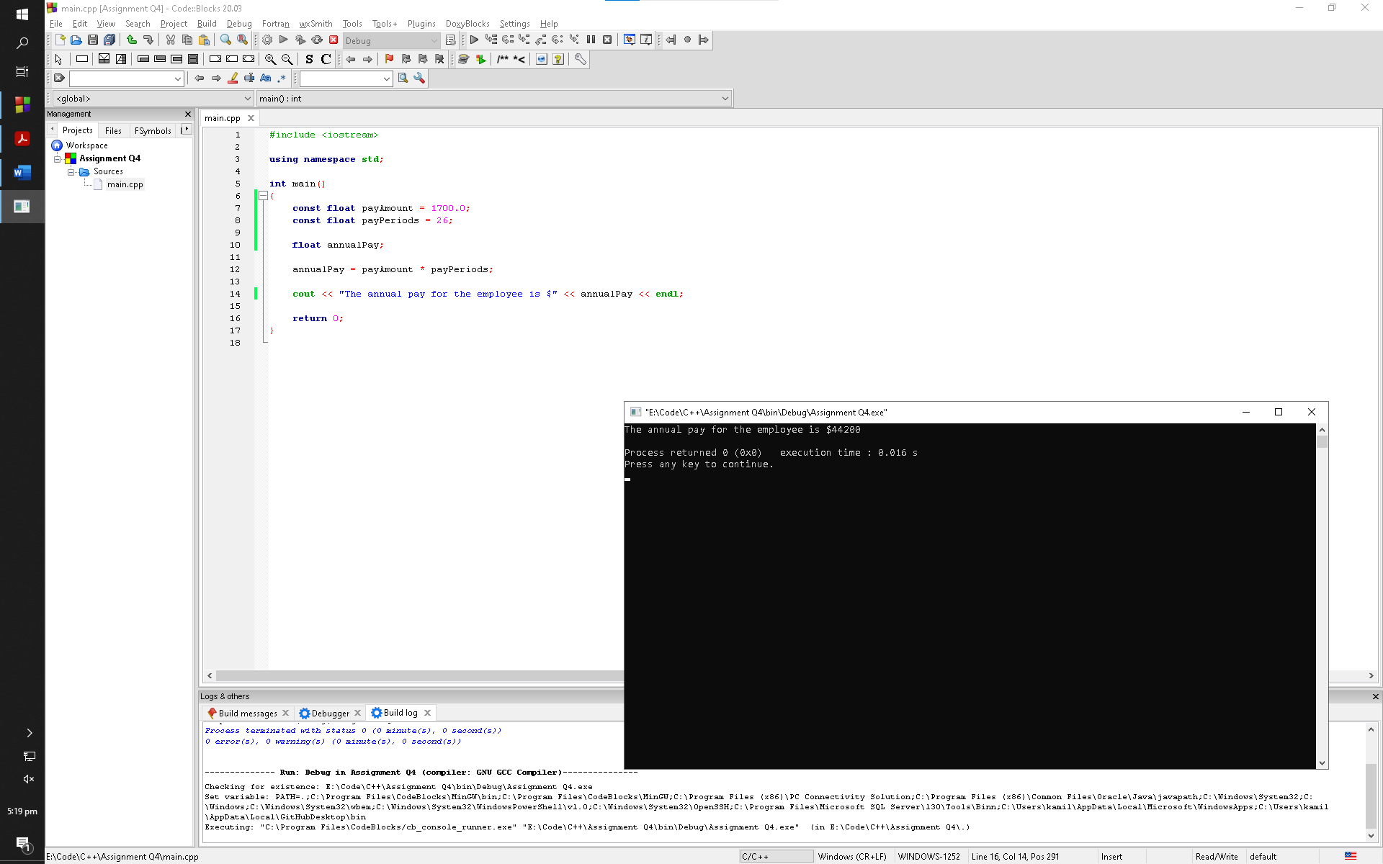

**Q5**

A customer in a store is purchasing five items. The prices of the five items are:

Price of item 1 = $12.95

Price of item 2 = $24.95

Price of item 3 = $6.95

Price of item 4 = $14.95

Price of item 5 = $3.95

Write a program that holds the prices of the five items in five variables. Display each item’s price, the subtotal of the sale, the amount of sales tax, and the total. Assume the sales tax is 6%.

**Code:**

1. #include <iostream>
2. #include <iomanip>
4. using namespace std;
6. int main()
7. {
8. const float item1 = 12.95;
9. const float item2 = 24.95;
10. const float item3 = 6.95;
11. const float item4 = 14.95;
12. const float item5 = 3.95;
13. const float tax = 0.06;
15. float subTotal, salesTax, total;
17. cout << "Price of item 1 is $12.95" << endl;
18. cout << "Price of item 2 is $24.95" << endl;
19. cout << "Price of item 3 is $6.95" << endl;
20. cout << "Price of item 4 is $14.95" << endl;
21. cout << "Price of item 5 is $3.95" << endl << endl;
23. subTotal = item1 + item2 + item3 + item4 + item5;
24. salesTax = subTotal * tax;
25. total = salesTax + subTotal;
27. cout << setprecision(2) << fixed;
29. cout << "Subtotal of the sale is $" << subTotal << endl;
30. cout << "Amount of sales tax is $" << salesTax << endl;
31. cout << "The total is $" << total << endl;
33. return 0;
34. }

**Output Window:**

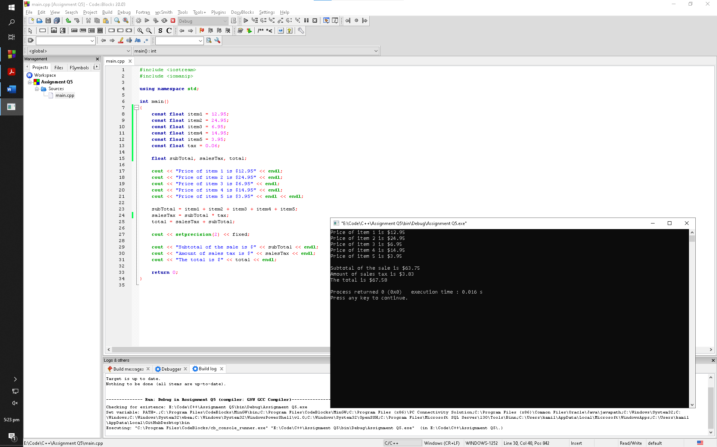

**Q6:**

Kathryn bought 600 shares of stock at a price of $21.77 per share. She must pay her stock broker a 2 percent commission for the transaction. Write a program that calculates and displays the following:

**•** The amount paid for the stock alone (without the commission)

**•** The amount of the commission

**•** The total amount paid (for the stock plus the commission)

**Code:**

1. #include <iostream>
3. using namespace std;
5. int main()
6. {
7. const float shares = 600;
8. const float sharePrice = 21.77;
9. const float commissionP = 0.02;
11. float stockPrice, aPrice, commission, total;
13. aPrice = shares * sharePrice;
15. cout << "Number of shares of stock purchased are " << shares << endl;
16. cout << "Amount per share is $" << sharePrice << endl;
17. cout << "Accumulated amount of all shares is $" << aPrice << endl << endl;
19. commission = aPrice * commissionP;
20. cout << "Amount of total commission is $" << commission << endl;
22. total = aPrice + commission;
23. cout << "Total amount to be paid is $" << total <<endl;
25. return 0;
26. }

**Output Window:**

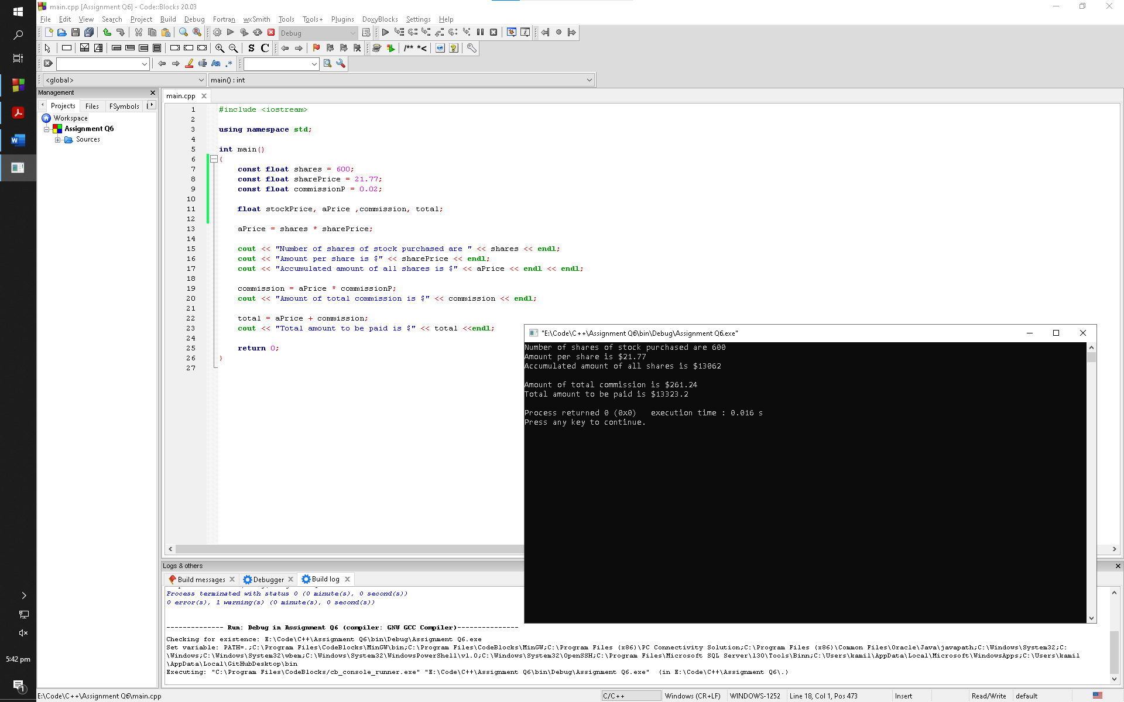

**Q7:**

A soft drink company recently surveyed 12,467 of its customers and found that approximately 14 percent of those surveyed purchase one or more energy drinks per week. Of those customers who purchase energy drinks, approximately 64 percent of them prefer citrus flavoured energy drinks. Write a program that displays the following:

**•** The approximate number of customers in the survey who purchase one or more energy drinks per week

**•** The approximate number of customers in the survey who prefer citrus flavoured energy drinks

**Code:**

1. #include <iostream>
2. #include <iomanip>
4. using namespace std;
6. int main()
7. {
8. const float numOfCustomers = 12467;
9. const float firstP = 0.14;
10. const float secondP = 0.64;
12. float drinkCustomers, citrusCustomers;
14. cout << setprecision(0) << fixed;
16. drinkCustomers = numOfCustomers * firstP;
17. cout << "Number of customers who purchase one or more energy drinks per week are " << drinkCustomers << endl;
19. citrusCustomers = drinkCustomers * secondP;
20. cout << "Number of customers who prefer citrus flavored energy drinks are " << citrusCustomers << endl;
22. return 0;
23. }

**Output Window:**

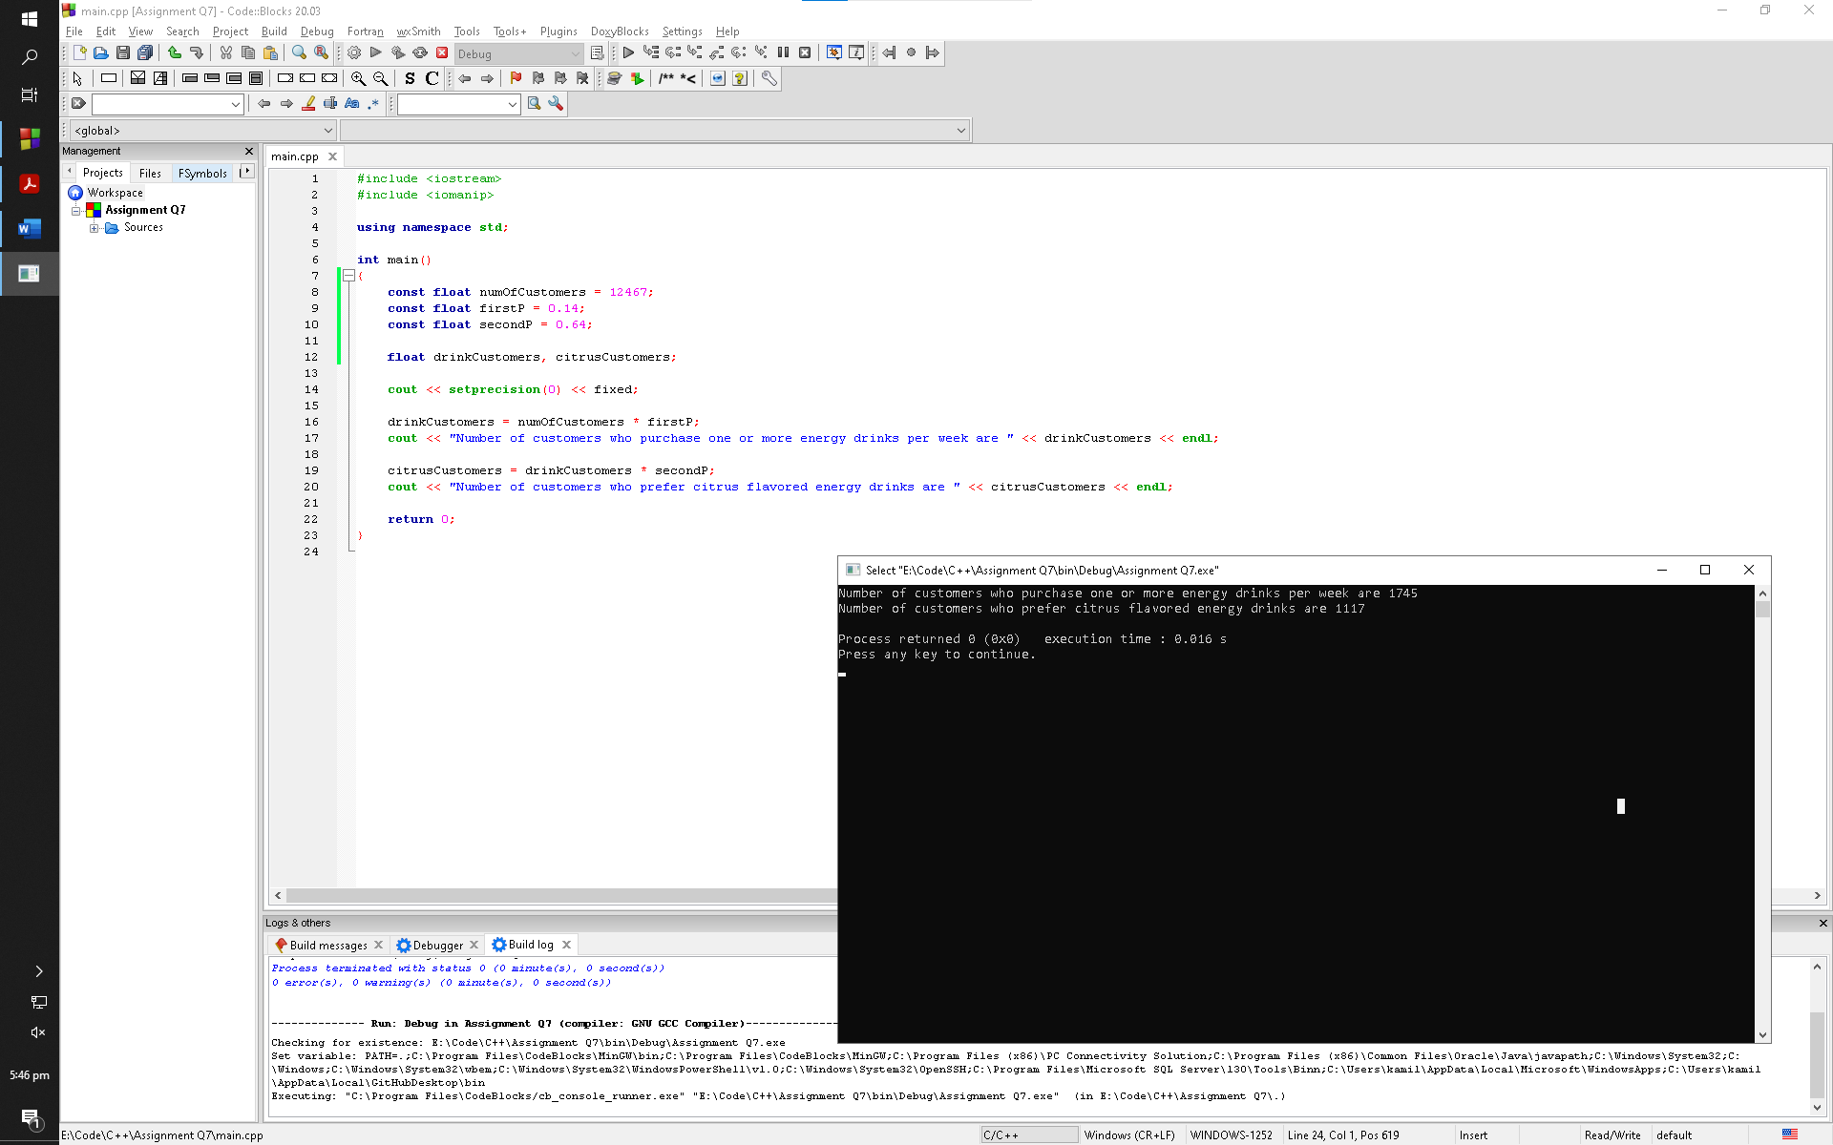

**Q8:**

A retail store grants its customers a maximum amount of credit. Each customer’s available credit is his or her maximum amount of credit minus the amount of credit used. Write a pseudocode algorithm for a program that asks for a customer’s maximum amount of credit and amount of credit used. The program should then display the customer’s available credit.

After you write the pseudocode algorithm, convert it to a complete C++ program.

**Code:**

1. #include <iostream>
3. using namespace std;
5. int main()
6. {
7. float creditMax, creditUsed, creditAvailable;
9. cout << "Input the maximum amount of credits: ";
10. cin >> creditMax;
12. cout << "Input the amount of credit used: ";
13. cin >> creditUsed;
15. cout << endl;
17. creditAvailable = creditMax - creditUsed;
18. cout << "Total number of available credits are " << creditAvailable << endl;
20. return 0;
21. }

**Output Window:**

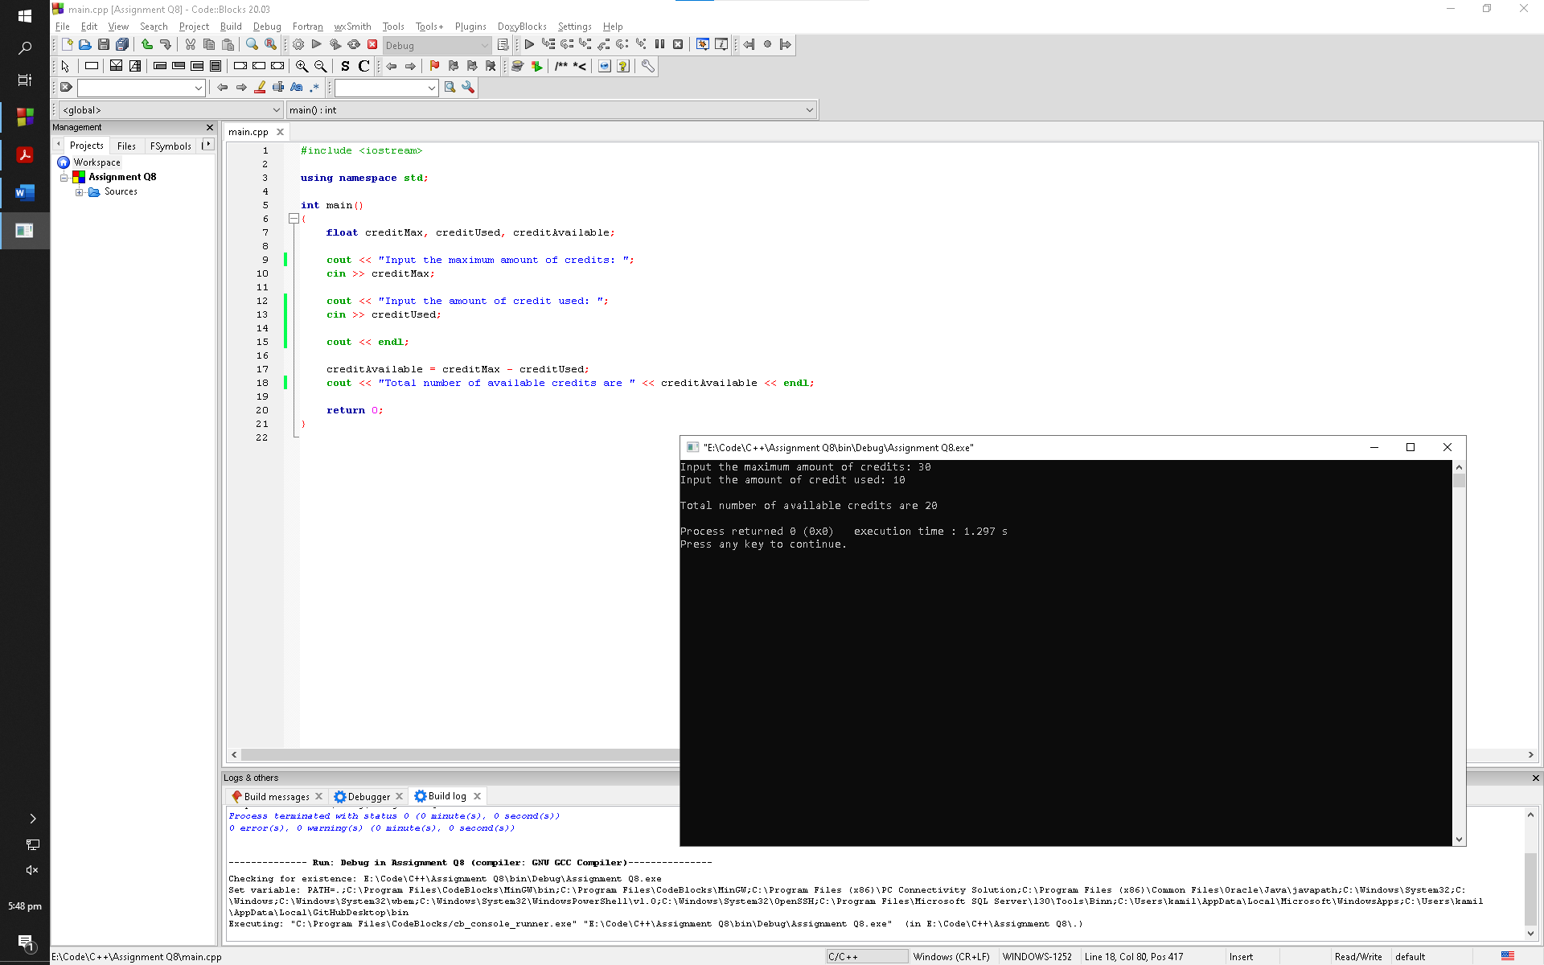

**Q9:**

Write a pseudocode algorithm for a program that calculates the total of a retail sale.

The program should ask for the amount of the sale and the sales tax rate. The sales tax rate should be entered as a floating-point number. For example, if the sales tax rate is 6 percent, the user should enter 0.06. The program should display the amount of sales tax and the total of the sale.

After you write the pseudocode algorithm, convert it to a complete C++ program.

**Code:**

1. #include <iostream>
3. using namespace std;
5. int main()
6. {
7. float amountSale, saleRate, amountTax, total;
9. cout << "What is the sale tax rate (If the sales tax rate is 6%, enter 0.06): ";
10. cin >> saleRate;
12. cout << "What is your amount of sale: ";
13. cin >> amountSale;
15. amountTax = amountSale * saleRate;
16. total = amountSale + amountTax;
17. cout << endl;
18. cout << "The amount of sale is $" << amountTax << " and the total with sales tax included is $" << total << endl;
20. return 0;
21. }

**Output Window:**

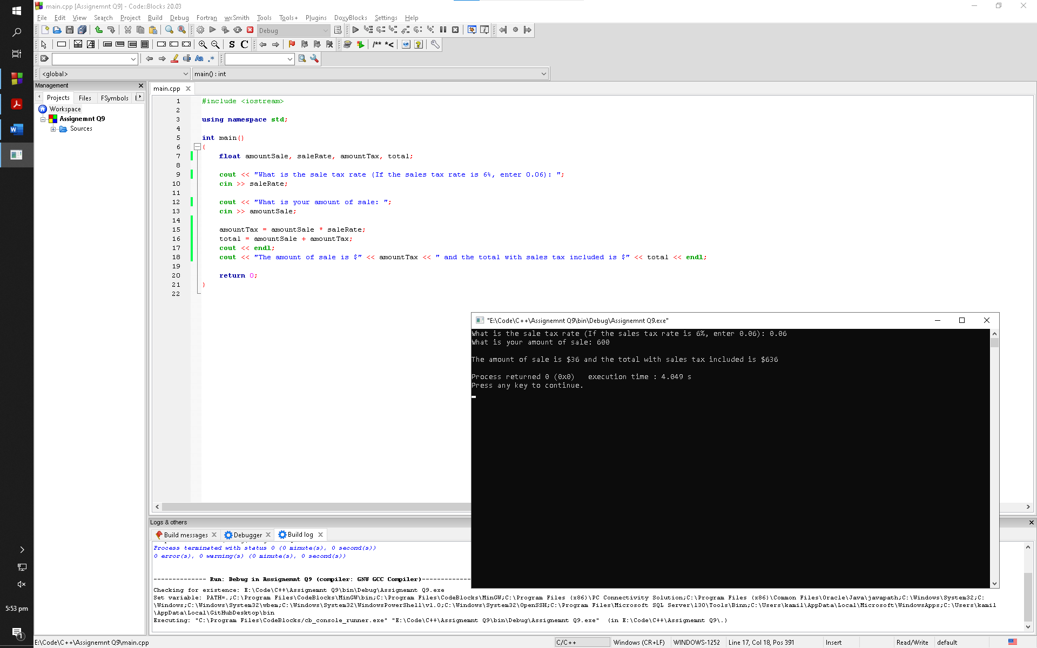

**Q10:**

Write a program that calculates a car’s gas mileage. The program should ask the user to enter the number of gallons of gas the car can hold, and the number of miles it can be driven on a full tank. It should then display the number of miles that may be driven per gallon of gas.

**Code:**

1. #include <iostream>
3. using namespace std;
5. int main()
6. {
7. float gasGallons, numMiles, mileage;
9. cout << "Input the number of gallons of gas the car can hold: ";
10. cin >> gasGallons;
12. cout << "Input the miles the car can be driven on full tank: ";
13. cin >> numMiles;
15. mileage = numMiles / gasGallons;
17. cout << endl;
18. cout << "Your car has a mileage of " << mileage << " miles per gallon" << endl;
20. return 0;
21. }

**Output Window:**

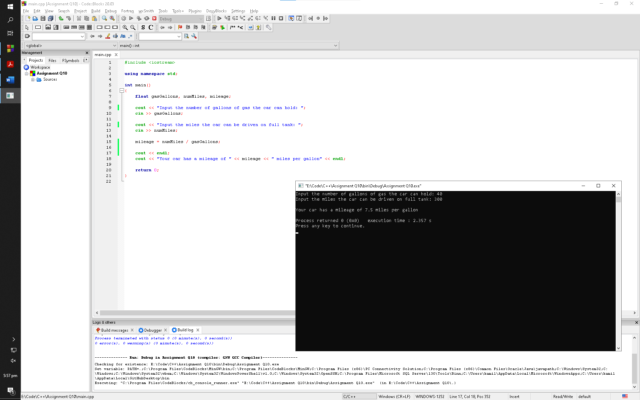

**Q11:**

There are three seating categories at a stadium. For a softball game, Class A seats cost

$15, Class B seats cost $12, and Class C seats cost $9. Write a program that asks how many tickets for each class of seats were sold, then displays the amount of income generated from ticket sales. Format your dollar amount in fixed-point notation, with two decimal places of precision, and be sure the decimal point is always displayed.

**Code:**

1. #include <iostream>
2. #include <iomanip>
4. using namespace std;
6. int main()
7. {
8. const float A = 15;
9. const float B = 12;
10. const float C = 9;
12. float ticketsA, ticketsB, ticketsC, total;
14. cout << "Enter how many class A tickets were sold: ";
15. cin >> ticketsA;
17. cout << "Enter how many class B tickets were sold: ";
18. cin >> ticketsB;
20. cout << "Enter how many class C tickets were sold: ";
21. cin >> ticketsC;
23. total = (A * ticketsA) + (B * ticketsB) + (C * ticketsC);
25. cout << setprecision(2) << fixed << endl;;
27. cout << "The total amount of income generated is $" << total << endl;
29. return 0;
30. }

**Output Window:**

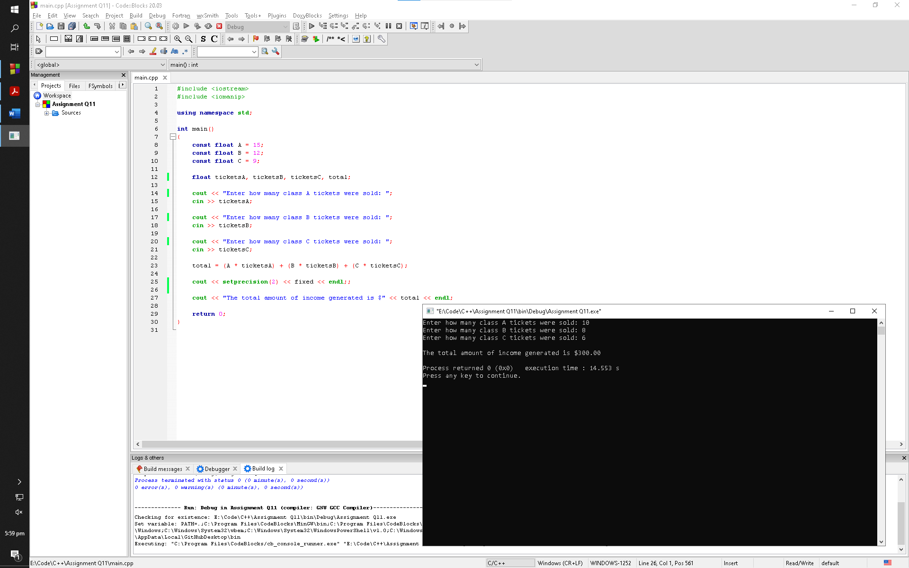

**Q12:**

Write a program that calculates the average rainfall for three months. The program should ask the user to enter the name of each month, such as June or July, and the amount of rain (in inches) that fell each month. The program should display a message similar to the following:

The average rainfall for June, July, and August is 6.72 inches.

**Code:**

1. #include <iostream>
3. using namespace std;
5. int main()
6. {
7. string month1, month2, month3;
8. float amount1, amount2, amount3, average;
10. cout << "Enter the name of first month: ";
11. cin >> month1;
12. cout << "Enter the amount of rainfall (in inches): ";
13. cin >> amount1;
14. cout << endl;
16. cout << "Enter the name of second month: ";
17. cin >> month2;
18. cout << "Enter the amount of rainfall (in inches): ";
19. cin >> amount2;
20. cout << endl;
22. cout << "Enter the name of third month: ";
23. cin >> month3;
24. cout << "Enter the amount of rainfall (in inches): ";
25. cin >> amount3;
26. cout << endl;
28. average = (amount1 + amount2 + amount3) / 3;
30. cout << "The average rainfall for months " << month1 << ", " << month2 << ", and " << month3 << " is " << average << " inches" << endl;
32. return 0;
33. }
34. Output

**Window:**

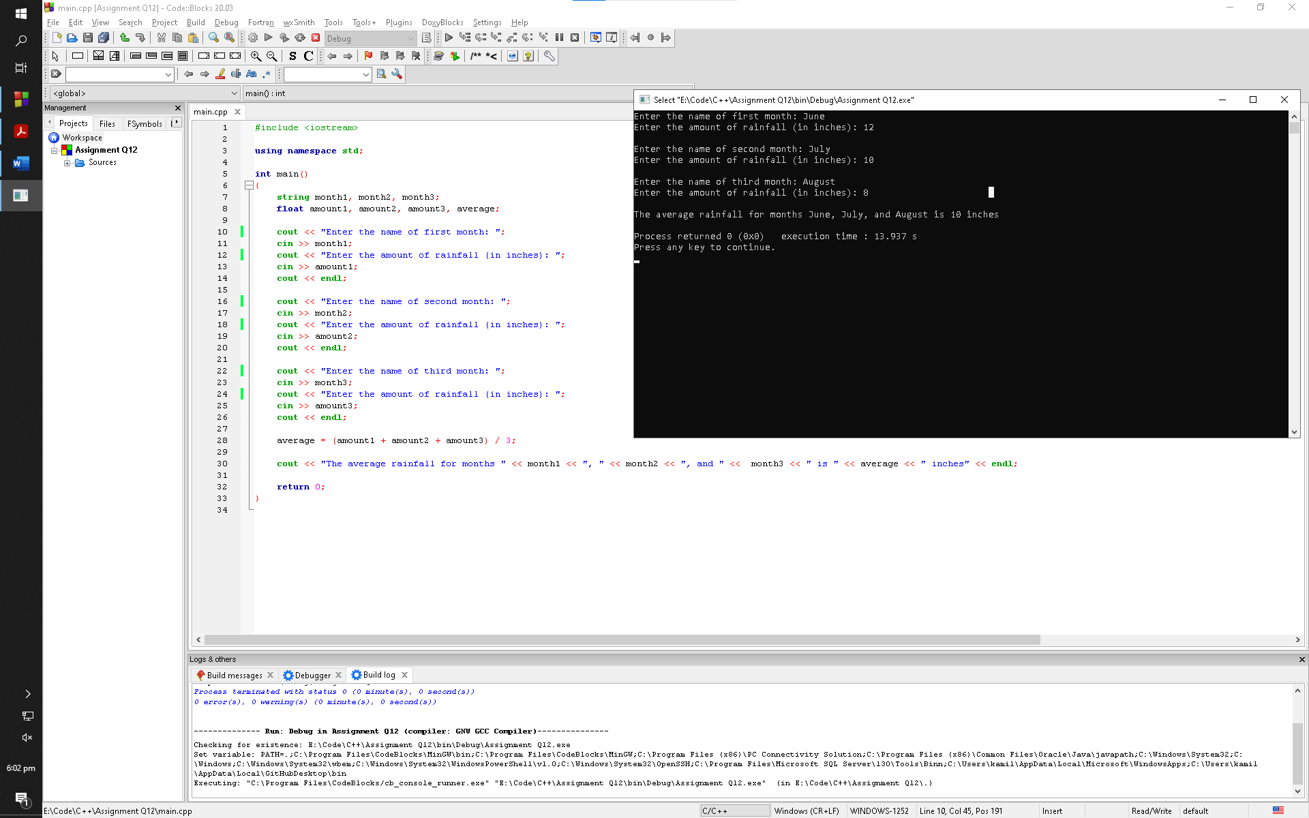

**Q13:**

A movie theatre only keeps a percentage of the revenue earned from ticket sales. The remainder goes to the movie distributor. Write a program that calculates a theatre’s gross and net box office profit for a night. The program should ask for the name of the movie, and how many adult and child tickets were sold. (The price of an adult ticket is $6.00 and a child’s ticket is $3.00.) It should display a report similar to

Movie Name: “Wheels of Fury”

Adult Tickets Sold: 382

Child Tickets Sold: 127

Gross Box Office Profit: $ 2673.00

Net Box Office Profit: $ 534.60

Amount Paid to Distributor: $ 2138.40

Assume the theatre keeps 20 percent of the gross box office profit.

**Code:**

1. #include <iostream>
2. #include <iomanip>
4. using namespace std;
6. int main()
7. {
8. const float grossProfitP = 0.20;
9. const float adultTicketPrice = 6;
10. const float childTicketPrice = 3;
12. string movieName;
13. float adultTickets, childTickets, grossProfit, netProfit, amountDistributor;
15. cout << "Enter the name of the movie: ";
16. getline(cin, movieName);
18. cout << "How many adult tickets were sold: ";
19. cin >> adultTickets;
21. cout << "How many child tickets were sold: ";
22. cin >> childTickets;
24. grossProfit = (adultTickets * adultTicketPrice) + (childTickets * childTicketPrice);
25. netProfit = grossProfit * grossProfitP;
26. amountDistributor = grossProfit - netProfit;
28. cout << endl;
30. cout << "Movie Name: " << setw(20) << "\"" << movieName << "\"" << endl;
31. cout << "Adult Tickets Sold: " << setw(14) << adultTickets << endl;
32. cout << "Child Tickets Sold: " << setw(14) << childTickets << endl;
34. cout << setprecision(2) << fixed;
36. cout << "Gross Box Office Profit: " << setw(7) << "$" << grossProfit << endl;
37. cout << "Net Box Office Profit: " << setw(9) << "$" << netProfit << endl;
38. cout << "Amount Paid to Distributor: " << setw(4) << "$" << amountDistributor << endl;
40. return 0;
41. }

**Output Window:**

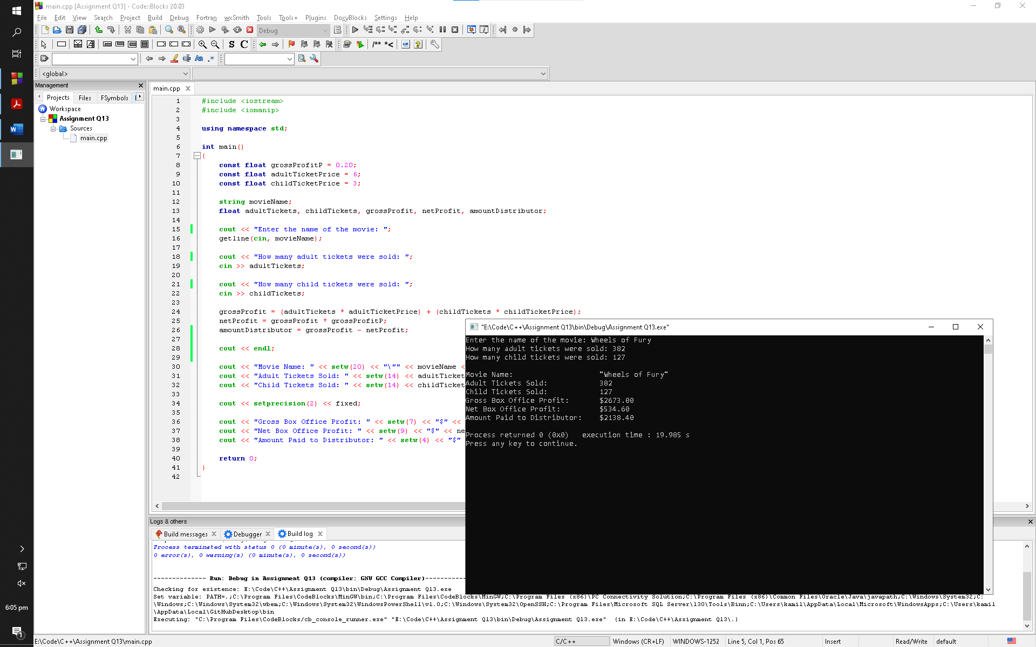

**Q14:**

The Yukon Widget Company manufactures widgets that weigh 9.2 pounds each.

Write a program that calculates how many widgets are stacked on a pallet, based on the total weight of the pallet. The program should ask the user how much the pallet weighs by itself and with the widgets stacked on it. It should then calculate and display the number of widgets stacked on the pallet.

**Code:**

1. #include <iostream>
2. #include <iomanip>
4. using namespace std;
6. int main()
7. {
8. const float weight = 9.2;
10. float withoutWeight, withWeight, widgetsWeight, numWidgets;
12. cout << "What is the weight of pallet without widgets stacked on it? (In pounds)" << endl;
13. cin >> withoutWeight;
15. cout << "What is the weight of pallet with widgets stacked on it? (In pounds)" << endl;
16. cin >> withWeight;
18. widgetsWeight = withWeight - withoutWeight;
19. numWidgets = widgetsWeight / weight;
21. cout << setprecision(0) << fixed;
23. cout << "Number of widgets stacked on the pallet are " << numWidgets << endl;
25. return 0;
26. }

**Output Window:**

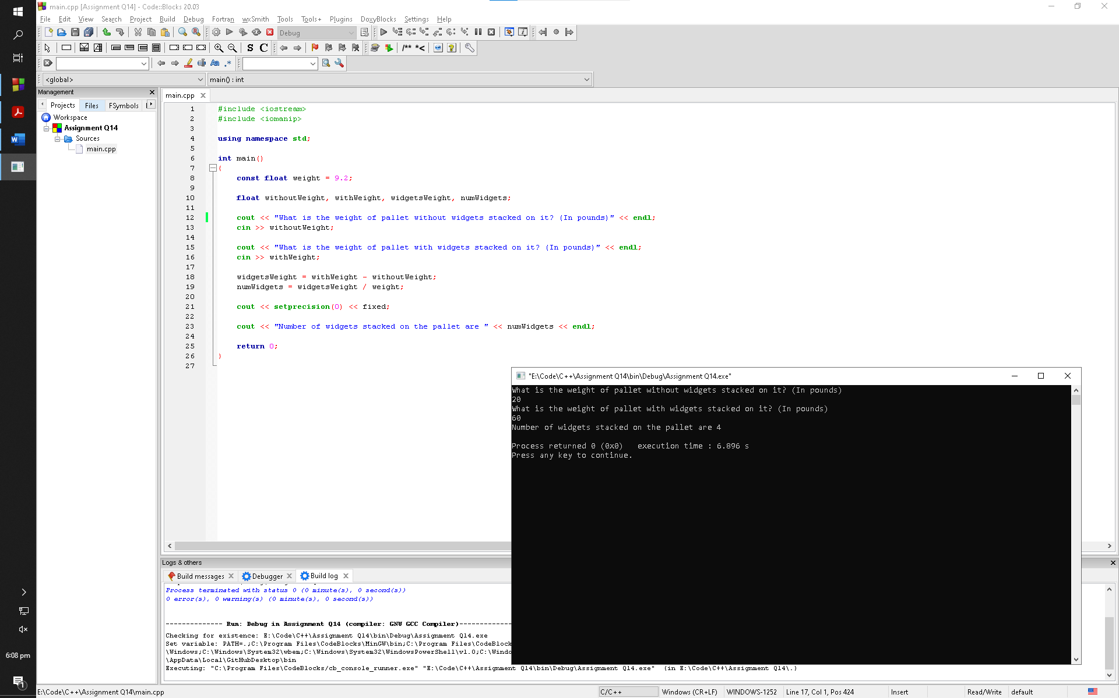

**Q15:**

Write a program that will convert U.S. dollar amounts to Japanese Yen and to Euros.

To get the most up-to-date exchange rates, search the Internet using the term “currency exchange rate”. If you cannot find the most recent exchange rates, use the following:

1 Dollar = 113.22 Yen

1 Dollar = 0.6936 Euros

Format your currency amounts in fixed-point notation, with two decimal places of precision, and be sure the decimal point is always displayed.

**Code:**

1. #include <iostream>
2. #include <iomanip>
4. using namespace std;
6. int main()
7. {
8. const float yenExchange = 103.84;
9. const float euroExchange = 0.82;
11. float dollar, yen, euros;
13. cout << "Input your amount in dollars: ";
14. cin >> dollar;
16. yen = dollar * yenExchange;
17. euros = dollar * euroExchange;
19. cout << setprecision(2) << fixed << showpoint;
21. cout << dollar << " Dollars = " << yen << " Yen" << endl;
22. cout << dollar << " Dollars = " << euros << " Euros" << endl;
24. return 0;
25. }

**Output Window:**

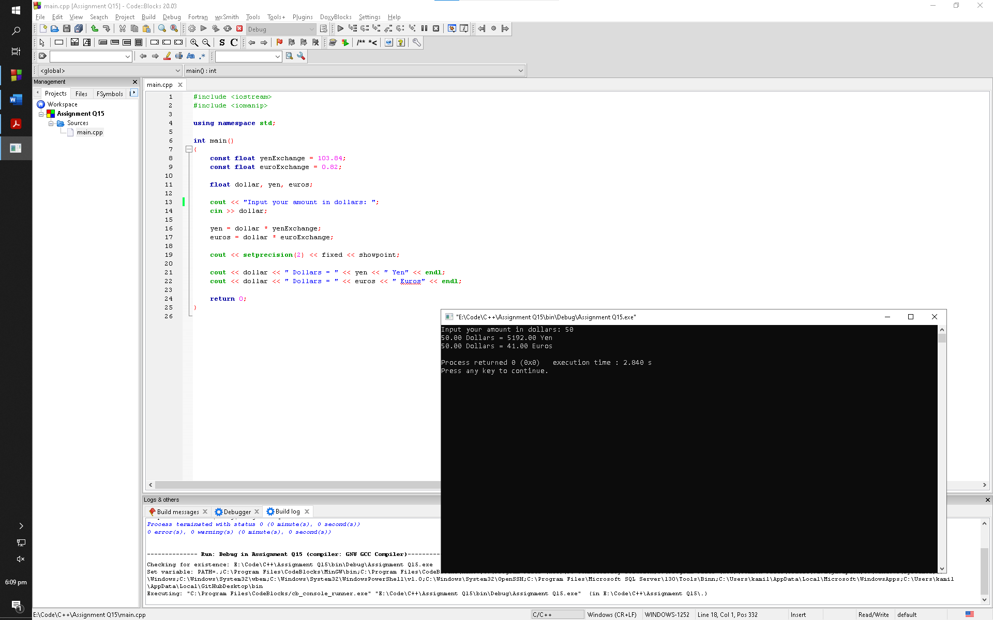

**Q16:**

A retail company must file a monthly sales tax report listing the sales for the month and the amount of sales tax collected. Write a program that asks for the month, the year, and the total amount collected at the cash register (that is, sales plus sales tax).

Assume the state sales tax is 4 percent and the county sales tax is 2 percent.

If the total amount collected is known and the total sales tax is 6 percent, the amount of product sales may be calculated as:

S = T/1.06

*S* is the product sales and *T* is the total income (product sales plus sales tax).

The program should display a report similar to

Month: October

--------------------------------------------------

Total Collected: $ 26572.89

Sales: $ 25068.76

County Sales Tax: $ 501.38

State Sales Tax: $ 1002.75

Total Sales Tax: $ 1504.13

**Code:**

1. #include <iostream>
2. #include <iomanip>
4. using namespace std;
6. int main()
7. {
8. const float countyTaxP = 0.02;
9. const float stateTaxP = 0.04;
11. string month;
12. int year;
13. float sales, productSales, countyTax, stateTax, totalTax;
15. cout << "Enter a month: ";
16. cin >> month;
18. cout << "Enter the year: ";
19. cin >> year;
21. cout << "Enter the total amount collected at the cash register: ";
22. cin >> sales;
24. cout << endl;
26. productSales = sales / 1.06;
27. countyTax = productSales * countyTaxP;
28. stateTax = productSales * stateTaxP;
29. totalTax = countyTax + stateTax;
31. cout << setw(32) << left << "Month: " << month << endl;
33. cout << setprecision(2) << fixed << showpoint;
34. cout << "--------------------------------------------" << endl;
36. cout << setw(32) << "Total Collected: " << "$" << sales << endl;
37. cout << setw(32) << "Sales: " << "$" << productSales << endl;
38. cout << setw(32) << "County Sales Tax: " << "$" << countyTax << endl;
39. cout << setw(32) << "State Sales Tax: " << "$" << stateTax << endl;
40. cout << setw(32) << "Total Sales Tax: " << "$" << totalTax << endl;
42. return 0;
43. }

**Output Window:**

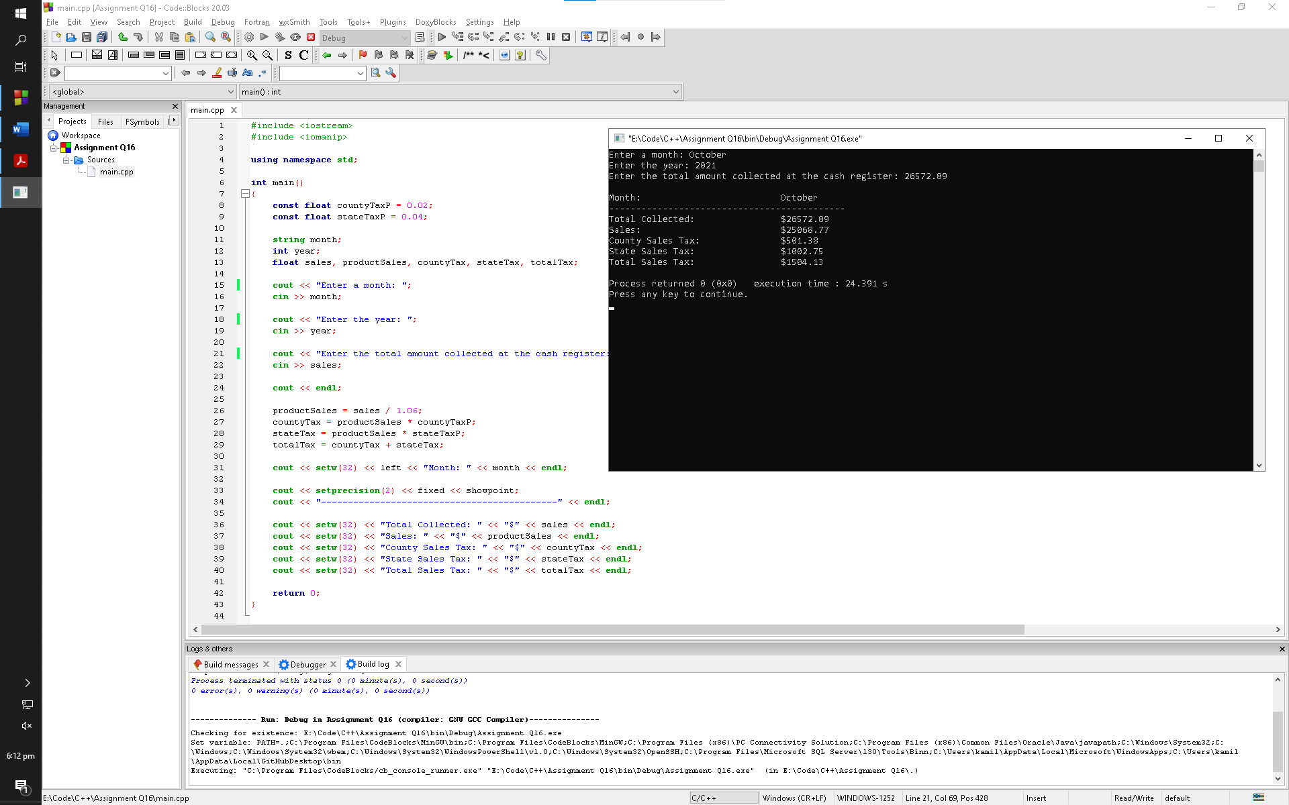

**Q17:**

Madison County provides a $5,000 homeowner exemption for its senior citizens.

For example, if a senior’s house is valued at $158,000 its assessed value would be $94,800, as explained above. However, he would only pay tax on $89,800. At last year’s tax rate of $2.64 for each $100 of assessed value, the property tax would be $2,370.72. In addition to the tax break, senior citizens are allowed to pay their property tax in four equal payments. The quarterly payment due on this property would be $592.68. Write a program that asks the user to input the actual value of a piece of property and the current tax rate for each $100 of assessed value. The program should then calculate and report how much annual property tax a senior homeowner will be charged for this property and what the quarterly tax bill will be?

**Code:**

1. #include <iostream>
2. #include <iomanip>
4. using namespace std;
6. int main()
7. {
8. const float valueAssessedP = 0.6,
9. valueExempt = 5000,
10. assessedTaxPer = 100,
11. partitionTax = 4;
13. float valueActual, valueAssessed, taxRate, exempt, propertyTax, quarterTax;
15. cout << "Enter the actual value of the property: ";
16. cin >> valueActual;
18. cout << "Enter the current tax rate: ";
19. cin >> taxRate;
21. valueAssessed = valueActual * valueAssessedP;
22. exempt = valueAssessed - valueExempt;
23. propertyTax = (exempt / assessedTaxPer) * taxRate;
24. quarterTax = propertyTax / partitionTax;
26. cout << endl;
27. cout << setprecision(2) << fixed;
29. cout << setw(50) << left << "Actual value of the property: " << "$" << valueActual << endl;
30. cout << setw(50) << left << "Assessed value of the property: " << "$" << valueAssessed << endl;
31. cout << setw(50) << left << "Value the senior citizens have to pay tax on: " << "$" << exempt << endl;
32. cout << setw(50) << left << "Annual property tax: " << "$" << propertyTax << endl;
33. cout << setw(50) << left << "Quarterly property tax: " << "$" << quarterTax << endl;
35. return 0;
36. }

**Output Window:**

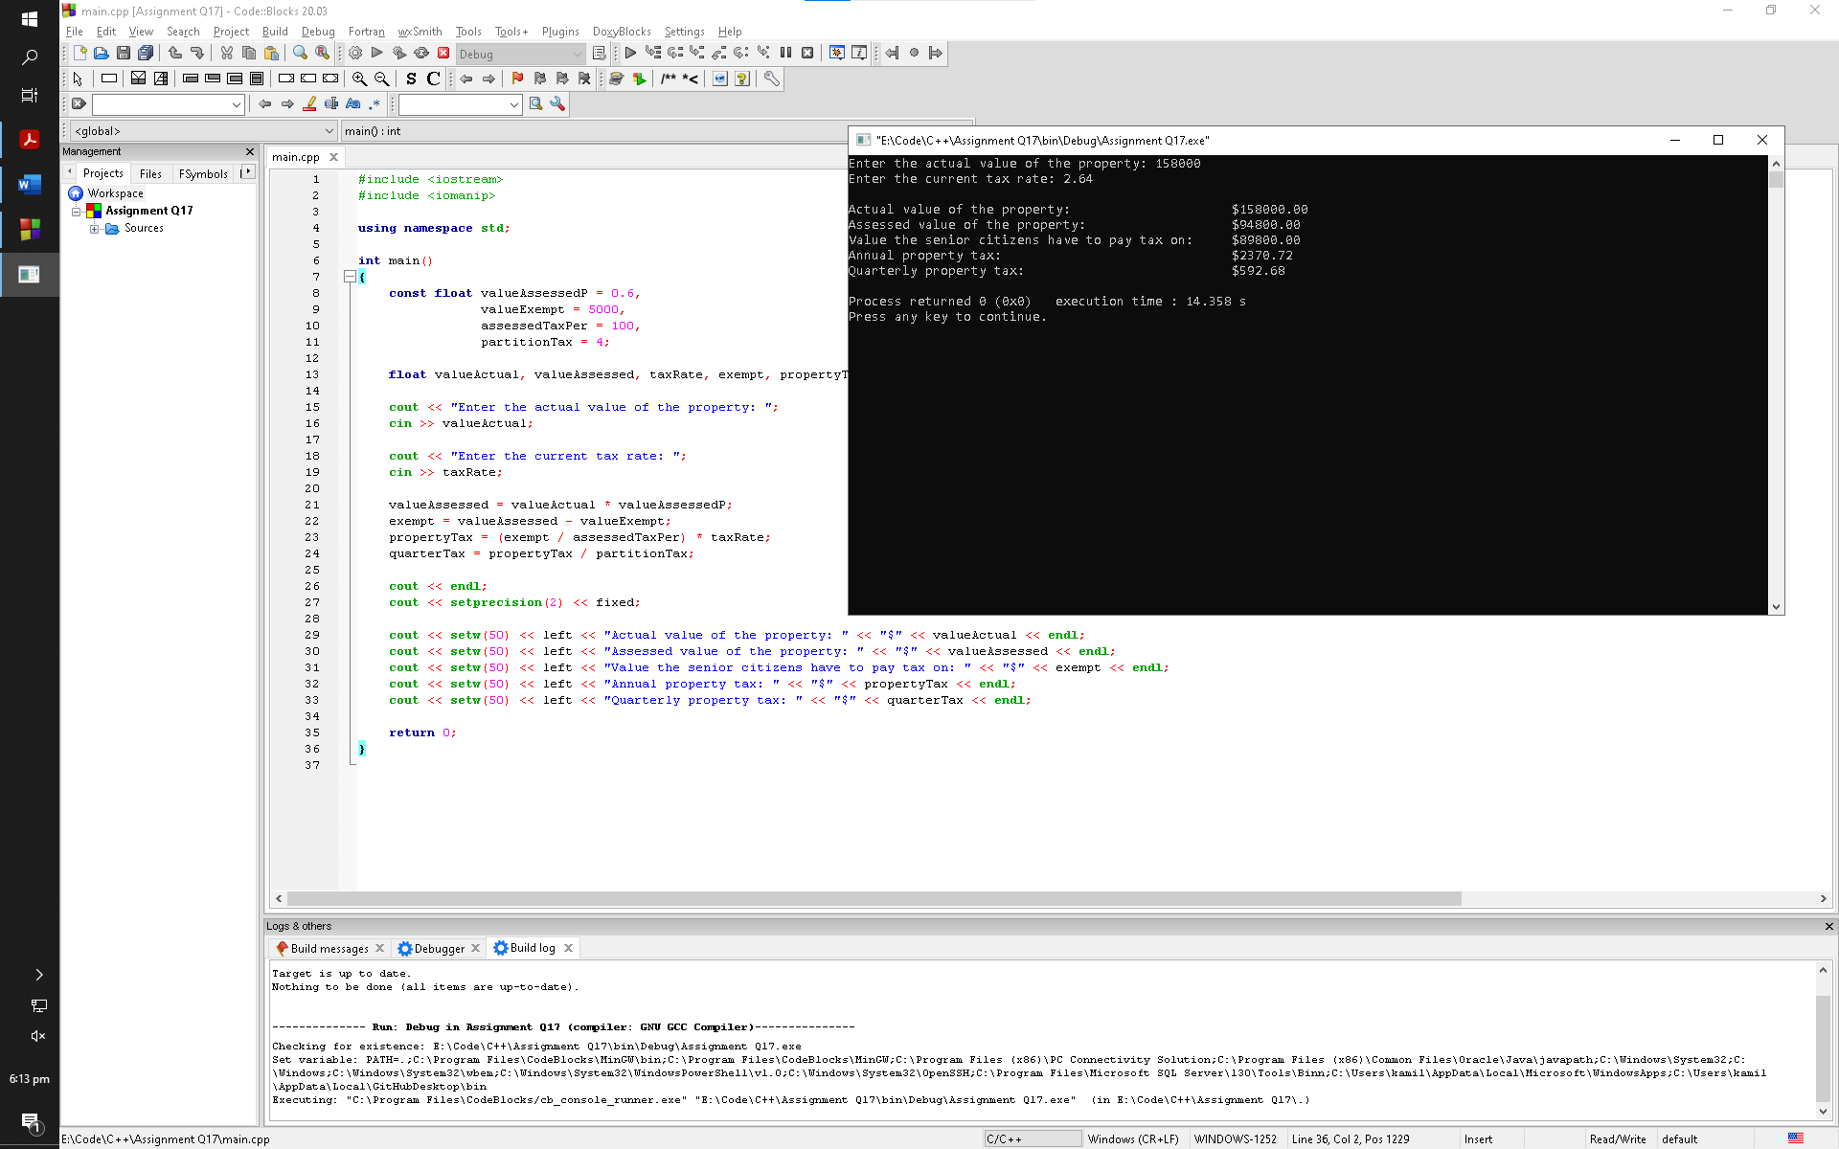

**Q18:**

Joe’s Pizza Palace needs a program to calculate the number of slices a pizza of any size can be divided into. The program should perform the following steps:

A) Ask the user for the diameter of the pizza in inches.

B) Calculate the number of slices that may be taken from a pizza of that size.

C) Display a message telling the number of slices.

To calculate the number of slices that may be taken from the pizza, you must know the following facts:

**•** Each slice should have an area of 14.125 inches.

**•** To calculate the number of slices, simply divide the area of the pizza by 14.125

Make sure the output of the program displays the number of slices in fixed point notation, rounded to one decimal place of precision. Use a named constant for pi.

**Code:**

1. #include <iostream>
2. #include <math.h>
3. #include <iomanip>
5. using namespace std;
7. int main()
8. {
9. const float areaSlice = 14.125;
11. float diameter, radius, area, numOfSlices;
13. cout << "Enter the diameter of the pizza in inches: ";
14. cin >> diameter;
16. radius = diameter / 2;
18. area = 3.142 * pow(radius, 2);
19. numOfSlices = area / areaSlice;
21. cout << setprecision(1) << fixed << endl;
23. cout << "Number of slices that may be taken form the pizza are " << numOfSlices << endl;
25. return 0;
26. }

**Output Window:**

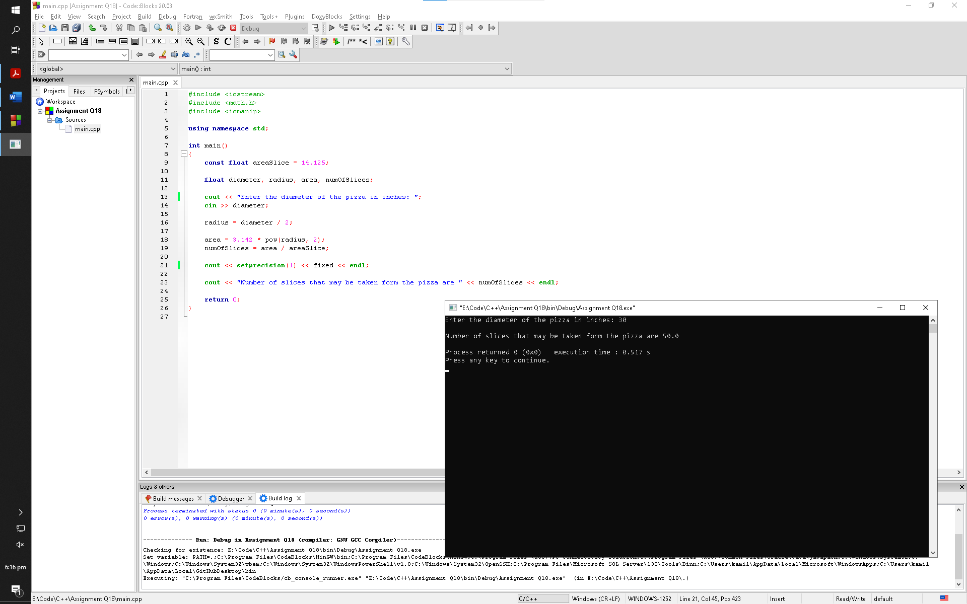

**Q19:**

Write a program that asks the user to enter a number of seconds.

**•** There are 60 seconds in a minute. If the number of seconds entered by the user is greater than or equal to 60, the program should display the number of minutes in that many seconds.

**•** There are 3,600 seconds in an hour. If the number of seconds entered by the user is greater than or equal to 3,600, the program should display the number of hours in that many seconds.

**•** There are 86,400 seconds in a day. If the number of seconds entered by the user is greater than or equal to 86,400, the program should display the number of days in that many seconds.

**Code:**

1. #include <iostream>
2. #include <iomanip>
4. using namespace std;
6. int main()
7. {
8. const int minSec = 60;
9. const int hourSec = 3600;
10. const int daySec = 86400;
12. float seconds, convertedSec;
14. cout << "Enter the number of seconds: ";
15. cin >> seconds;
17. cout << endl;
19. if (seconds >= 60 && seconds < 3600) {
20. convertedSec = seconds / minSec;
21. cout << seconds << " seconds are in " << setprecision(2) << fixed << convertedSec << " minutes" << endl;
22. }
23. else if (seconds >= 3600 && seconds < 86400) {
24. convertedSec = seconds / hourSec;
25. cout << seconds << " seconds are in " << setprecision(2) << fixed << convertedSec << " hours" << endl;
26. }
27. else if (seconds >= 86400){
28. convertedSec = seconds / daySec;
29. cout << seconds << " seconds are in " << setprecision(2) << fixed << convertedSec << " days" << endl;
30. }
32. return 0;
33. }

**Output Window:**

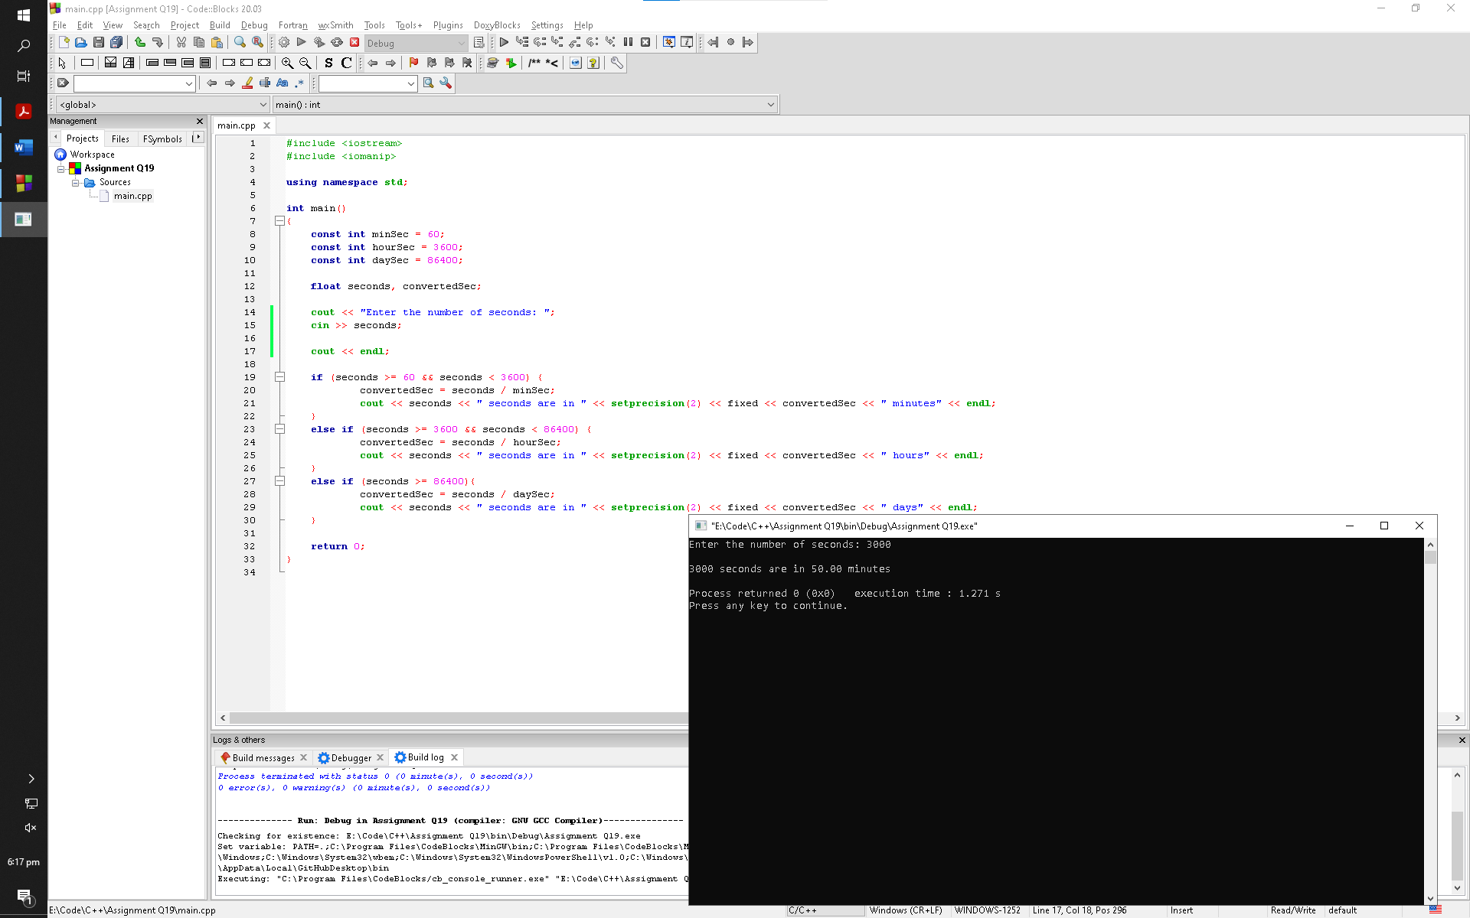

**Q20:**

Serendipity Booksellers has a book club that awards points to its customers based on the number of books purchased each month. The points are awarded as follows:

**•** If a customer purchases 0 books, he or she earns 0 points.

**•** If a customer purchases 1 book, he or she earns 5 points.

**•** If a customer purchases 2 books, he or she earns 15 points.

**•** If a customer purchases 3 books, he or she earns 30 points.

**•** If a customer purchases 4 or more books, he or she earns 60 points.

Write a program that asks the user to enter the number of books that he or she has purchased this month and then displays the number of points awarded

**Code:**

1. #include <iostream>
3. using namespace std;
5. int main()
6. {
7. int numOfBooks;
9. cout << "Enter the number of books purchased this month: ";
10. cin >> numOfBooks;
12. cout << endl;
14. if (numOfBooks == 0) {
15. cout << "You have earned 0 points" << endl;
16. }
17. else if (numOfBooks == 1) {
18. cout << "You have earned 5 points" << endl;
19. }
20. else if (numOfBooks == 2) {
21. cout << "You have earned 15 points" << endl;
22. }
23. else if (numOfBooks == 3) {
24. cout << "You have earned 30 points" << endl;
25. }
26. else if (numOfBooks >= 4) {
27. cout << "You have earned 60 points" << endl;
28. }
30. return 0;
31. }

**Output Window:**

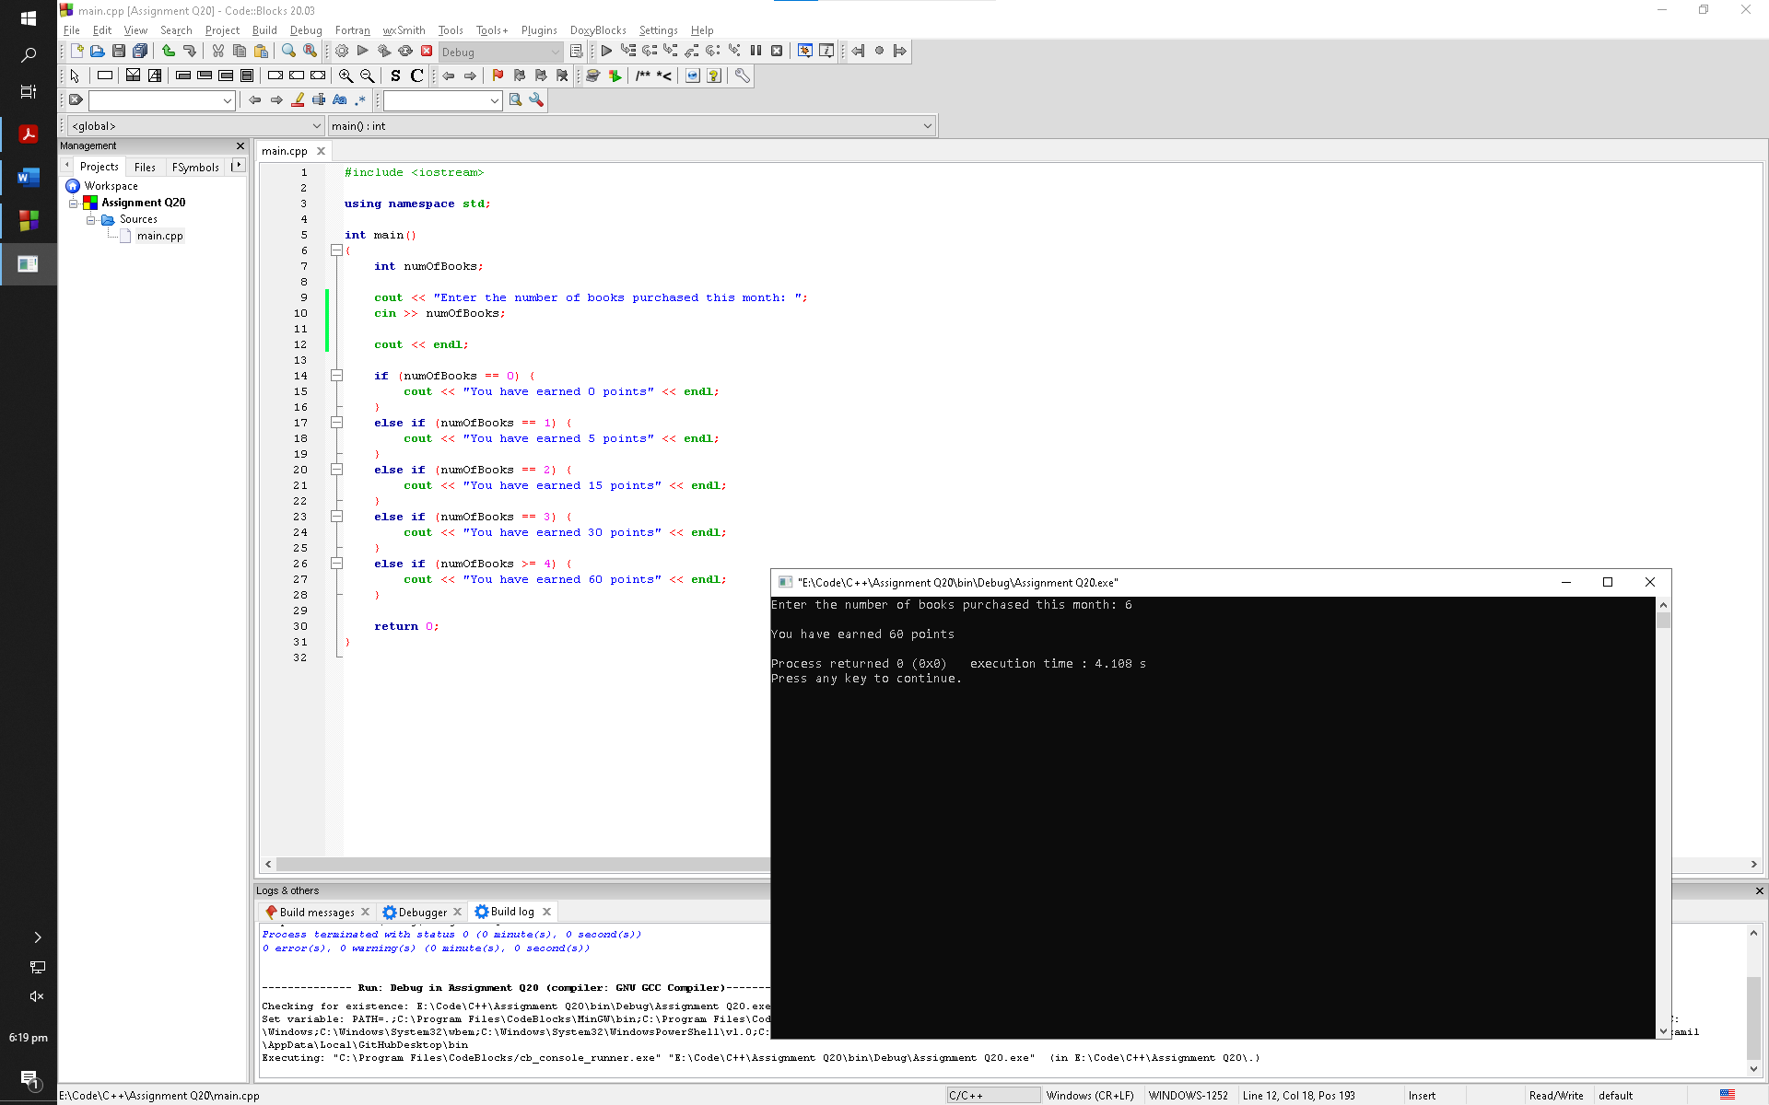

**Q21:**

The Fast Freight Shipping Company charges the following rates:

**Weight of Package (in Kilograms) Rate per 500 Miles Shipped**

2 Kg or less $1.10

Over 2 Kg but not more than 6 kg $2.20

Over 6 Kg but not more than 10 kg $3.70

Over 10 Kg but not more than 20 kg $4.80

Write a program that asks for the weight of the package and the distance it is to be shipped, and then displays the charges.

*Input Validation: Do not accept values of 0 or less for the weight of the package. Do not accept weights of more than 20 Kg (this is the maximum weight the company will ship). Do not accept distances of less than 10 miles or more than 3,000 miles. These are the company’s minimum and maximum shipping distances.*

**Code:**

1. #include <iostream>
3. using namespace std;
5. int main()
6. {
7. float weight, distance, rate;
9. cout << "Input the weight of the package: ";
10. cin >> weight;
12. cout << "Input the distance it needs to be shipped: ";
13. cin >> distance;
15. cout << endl;
17. if (weight > 0 && weight <= 2) {
18. if (distance >= 10 && distance <= 3000) {
19. rate = (distance * 1.10) / 500;
20. cout << "Estimated rate for weight " << weight << " kg to be shipped a distance of " << distance << " miles is $" << rate << endl;
21. }
22. else {
23. cout << "Error" << endl;
24. }
25. }
26. else if (weight > 2 && weight <= 6) {
27. if (distance >= 10 && distance <= 3000) {
28. rate = (distance * 2.20) / 500;
29. cout << "Estimated rate for weight " << weight << " kg to be shipped a distance of " << distance << " miles is $" << rate << endl;
30. }
31. else {
32. cout << "Error" << endl;
33. }
34. }
35. else if (weight > 6 && weight <= 10) {
36. if (distance >= 10 && distance <= 3000) {
37. rate = (distance * 3.70) / 500;
38. cout << "Estimated rate for weight " << weight << " kg to be shipped a distance of " << distance << " miles is $" << rate << endl;
39. }
40. else {
41. cout << "Error" << endl;
42. }
43. }
44. else if (weight > 10 && weight <= 20) {
45. if (distance >= 10 && distance <= 3000) {
46. rate = (distance * 4.80) / 500;
47. cout << "Estimated rate for weight " << weight << " kg to be shipped a distance of " << distance << " miles is $" << rate << endl;
48. }
49. else {
50. cout << "Error" << endl;
51. }
52. }
53. else {
54. cout << "Error" << endl;
55. }
57. return 0;
58. }

**Output Window:**

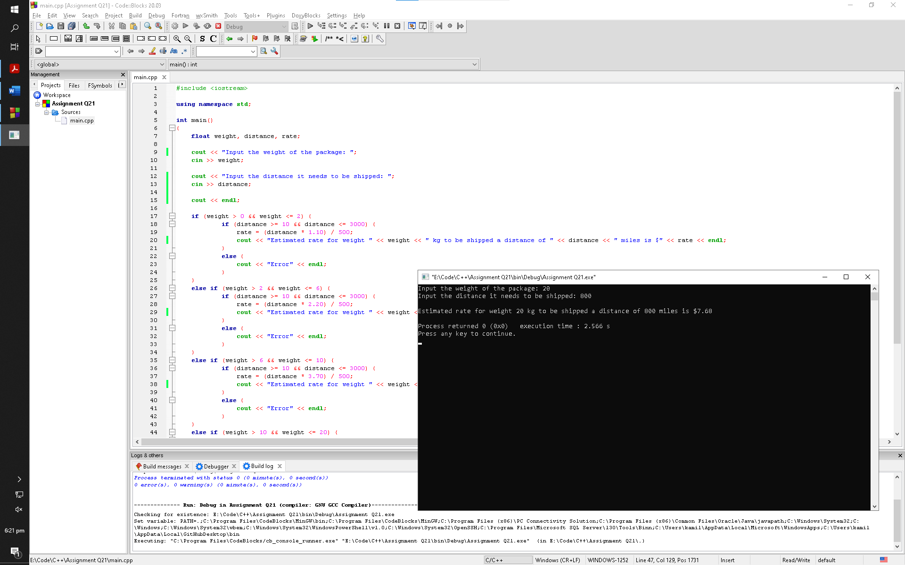

**Q22:**

Write a program that asks for the number of calories and fat grams in a food. The program should display the percentage of calories that come from fat. If the calories from fat are less than 30% of the total calories of the food, it should also display a message indicating that the food is low in fat.

One gram of fat has 9 calories, so

Calories from fat = fat grams * 9

The percentage of calories from fat can be calculated as

Calories from fat ÷ total calories

*Input Validation: Make sure the number of calories and fat grams are not less than 0.*

*Also, the number of calories from fat cannot be greater than the total number of calories.*

*If that happens, display an error message indicating that either the calories or fat grams were incorrectly entered.*

**Code:**

1. #include <iostream>
3. using namespace std;
5. int main()
6. {
7. float calories, fat, fatCalories, totalCalories, fatCaloriesP;
9. cout << "Enter the amount of calories present in this food: ";
10. cin >> calories;
12. cout << "Enter the amount of fat grams present in this food: ";
13. cin >> fat;
15. if (calories >= 0 && fat >= 0) {
17. fatCalories = fat * 9;
18. totalCalories = fatCalories + calories;
20. if (fatCalories < totalCalories) {
22. fatCaloriesP = (fatCalories / totalCalories) * 100;
24. cout << "Percentage of calories that come from fat is " << fatCaloriesP << "%" << endl;
26. if (fatCalories <= (0.30 * totalCalories)) {
27. cout << "The food is low in fat" << endl;
28. }
30. }
31. else {
32. cout << "Error. The calories or fat grams were incorrectly entered" << endl;
33. }
34. }
35. else {
36. cout << "Error" << endl;
37. }
39. return 0;
40. }

**Output Window:**

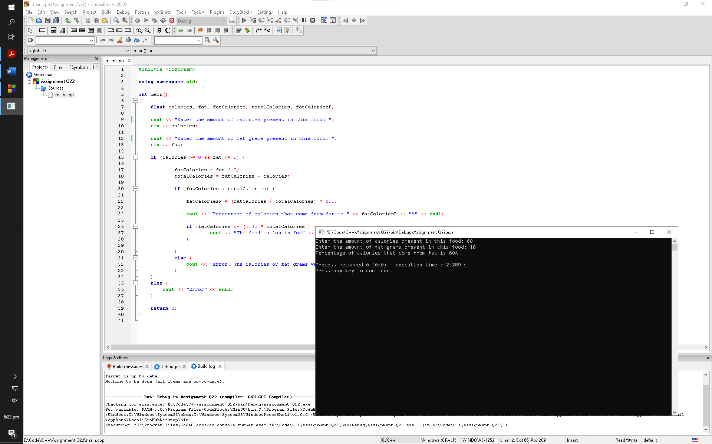

**Q23:**

When sound travels through a gas, its speed depends primarily on the density of the medium. The less dense the medium, the faster the speed will be. The following table shows the approximate speed of sound at 0 degrees centigrade, measured in meters per second, when traveling through carbon dioxide, air, helium, and hydrogen

**Medium Speed (Meters per Second)**

Carbon Dioxide 258.0

Air 331.5

Helium 972.0

Hydrogen 1,270.0

Write a program that displays a menu allowing the user to select one of these four gases. After a selection has been made, the user should enter the number of seconds it took for the sound to travel in this medium from its source to the location at which it was detected. The program should then report how far away (in meters) the source of the sound was from the detection location.

*Input Validation: Check that the user has selected one of the available menu choices.*

*Do not accept times less than 0 seconds or more than 30 seconds.*

**Code:**

1. #include <iostream>
2. #include <iomanip>
4. using namespace std;
6. int main()
7. {
8. const float speedCD = 258.0;
9. const float speedAir = 331.5;
10. const float speedHelium = 972.0;
11. const float speedHydrogen = 1270.0;
13. int sno;
14. float time, distance;
16. cout << "Choose a medium by typing their Sno accordingly" << endl;
18. cout << setprecision(1) << fixed;
20. cout << setw(10) << left << "Sno";
21. cout << setw(25) << left << "Medium" << "Speed (Meters per Second)" << endl;
23. cout << "-------------------------------------------------------------" << endl;
25. cout << setw(10) << left << "1";
26. cout << setw(25) << left << "Carbon Dioxide" << speedCD << endl;
28. cout << setw(10) << left << "2";
29. cout << setw(25) << left << "Air" << speedAir << endl;
31. cout << setw(10) << left << "3";
32. cout << setw(25) << left << "Helium" << speedHelium << endl;
34. cout << setw(10) << left << "4";
35. cout << setw(25) << left << "Hydrogen" << speedHydrogen << endl << endl;
37. cout << setprecision(0) << fixed;
39. cin >> sno;
41. if (sno == 1) {
42. cout << "Enter the number of seconds it took for the sound to travel in this medium from its source to the location at which it was detected: ";
43. cin >> time;
45. cout << endl;
47. if (time >= 0 || time <= 30) {
48. distance = speedCD * time;
50. cout << "The source of the sound from the detection location was " << distance << " meters away" << endl;
51. }
52. else {
53. cout << "Error" << endl;
54. }
55. }
56. else if (sno == 2) {
57. cout << "Enter the number of seconds it took for the sound to travel in this medium from its source to the location at which it was detected: ";
58. cin >> time;
60. cout << endl;
62. if (time >= 0 || time <= 30) {
63. distance = speedAir * time;
65. cout << "The source of the sound from the detection location was " << distance << " meters away" << endl;
66. }
67. else {
68. cout << "Error" << endl;
69. }
70. }
71. else if (sno == 3) {
72. cout << "Enter the number of seconds it took for the sound to travel in this medium from its source to the location at which it was detected: ";
73. cin >> time;
75. cout << endl;
77. if (time >= 0 || time <= 30) {
78. distance = speedHelium * time;
80. cout << "The source of the sound from the detection location was " << distance << " meters away" << endl;
81. }
82. else {
83. cout << "Error" << endl;
84. }
85. }
86. else if (sno == 4) {
87. cout << "Enter the number of seconds it took for the sound to travel in this medium from its source to the location at which it was detected: ";
88. cin >> time;
90. cout << endl;
92. if (time >= 0 || time <= 30) {
93. distance = speedHydrogen * time;
95. cout << "The source of the sound from the detection location was " << distance << " meters away" << endl;
96. }
97. else {
98. cout << "Error" << endl;
99. }
100. }
101. else {
102. cout << "Error" << endl;
103. }
105. return 0;
106. }

**Output Window:**

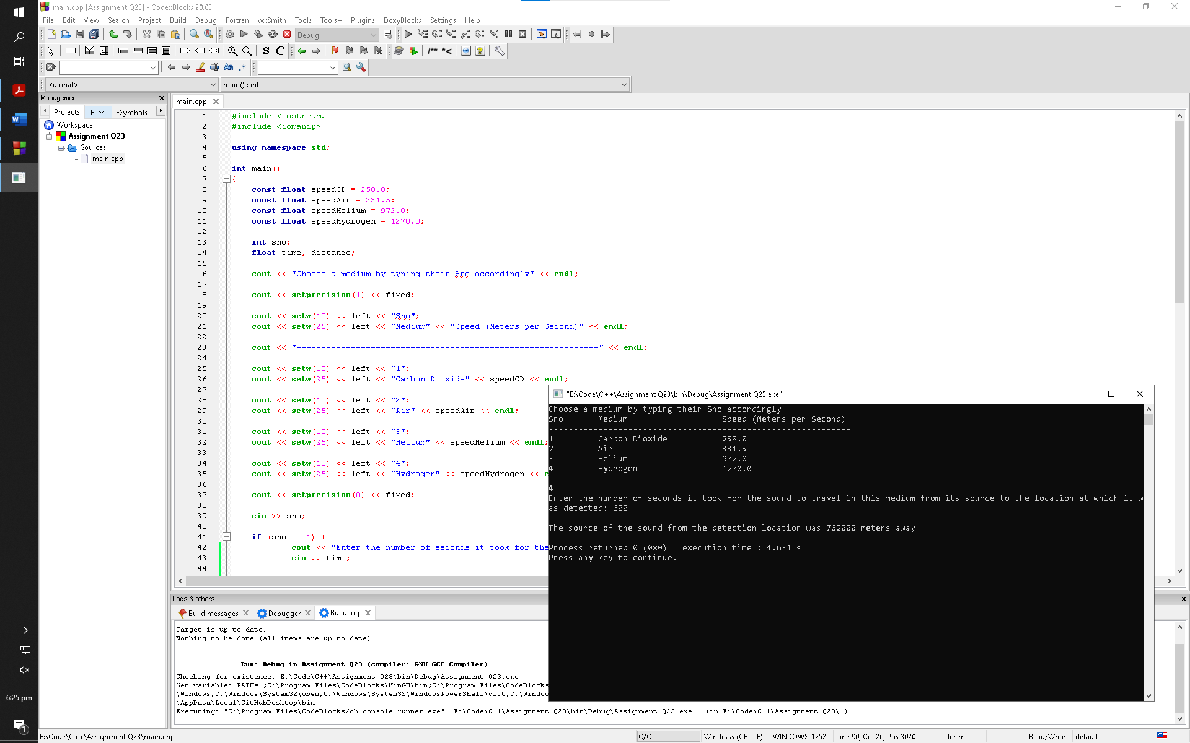

**Q24:**

An Internet service provider has three different subscription packages for its customers:

Package A: For $9.95 per month 10 hours of access are provided. Additional hours are $2.00 per hour.

Package B: For $14.95 per month 20 hours of access are provided. Additional hours are $1.00 per hour.

Package C: For $19.95 per month unlimited access is provided.

Write a program that calculates a customer’s monthly bill. It should ask which package the customer has purchased and how many hours were used. It should then display the total amount due.

*Input Validation: Be sure the user only selects package A, B, or C. Also, the number of hours used in a month cannot exceed 744.*

**Code:**

1. #include <iostream>
3. using namespace std;
5. int main()
6. {
7. const float packAbill = 9.95,
8. packAbillAdd = 2.00,
9. hoursA = 10;
11. const float packBbill = 14.95,
12. packBbillAdd = 1.00,
13. hoursB = 20;
15. const float packCbill = 19.95;
17. const float hoursMax = 744;
19. char packType;
20. float hours, bill, hoursAdd;
22. cout << "What is the package the customer has purchased?" << endl;
23. cout << "Type 'A' for Package A" << endl;
24. cout << "Type 'B' for Package B" << endl;
25. cout << "Type 'C' for Package C" << endl << endl;
26. cout << "Choose package: ";
27. cin >> packType;
29. if (packType == 'A' || packType == 'B' || packType == 'C') {
30. cout << "How many hours were used: ";
31. cin >> hours;
33. cout << endl;
35. if (packType == 'A') {
36. if (hours <= hoursA) {
37. bill = packAbill;
39. cout << "Your monthly bill on Package A for " << hours << " hours is $" << bill << endl;
40. }
41. else if (hours <= hoursMax) {
42. hoursAdd = hours - hoursA;
43. bill = (hoursAdd * packAbillAdd) + packAbill;
45. cout << "Your monthly bill on Package A for " << hours << " hours (" << hoursA << " package hours + " << hoursAdd << " additional hours) is $" << bill << endl;
46. }
47. else {
48. cout << "Error, the hours you entered are incorrect" << endl;
49. }
50. }
51. else if (packType == 'B') {
52. if (hours <= hoursB) {
53. bill = packBbill;
55. cout << "Your monthly bill on Package B for " << hours << " hours is $" << bill << endl;
56. }
57. else if (hours <= hoursMax) {
58. hoursAdd = hours - hoursB;
59. bill = (hoursAdd * packBbillAdd) + packBbill;
61. cout << "Your monthly bill on Package B for " << hours << " hours (" << hoursB << " package hours + " << hoursAdd << " additional hours) is $" << bill << endl;
62. }
63. else {
64. cout << "Error, the hours you entered are incorrect" << endl;
65. }
66. }
67. else if (packType == 'C') {
68. if (hours <= hoursMax) {
69. bill = packCbill;
71. cout << "Your monthly bill on Package C for " << hours << " hours is $" << bill << endl;
72. }
73. else {
74. cout << "Error, the hours you entered are incorrect" << endl;
75. }
76. }
77. }
78. else {
79. cout << "Error, the package you entered is incorrect" << endl;
80. }
82. return 0;
83. }

**Output Window:**

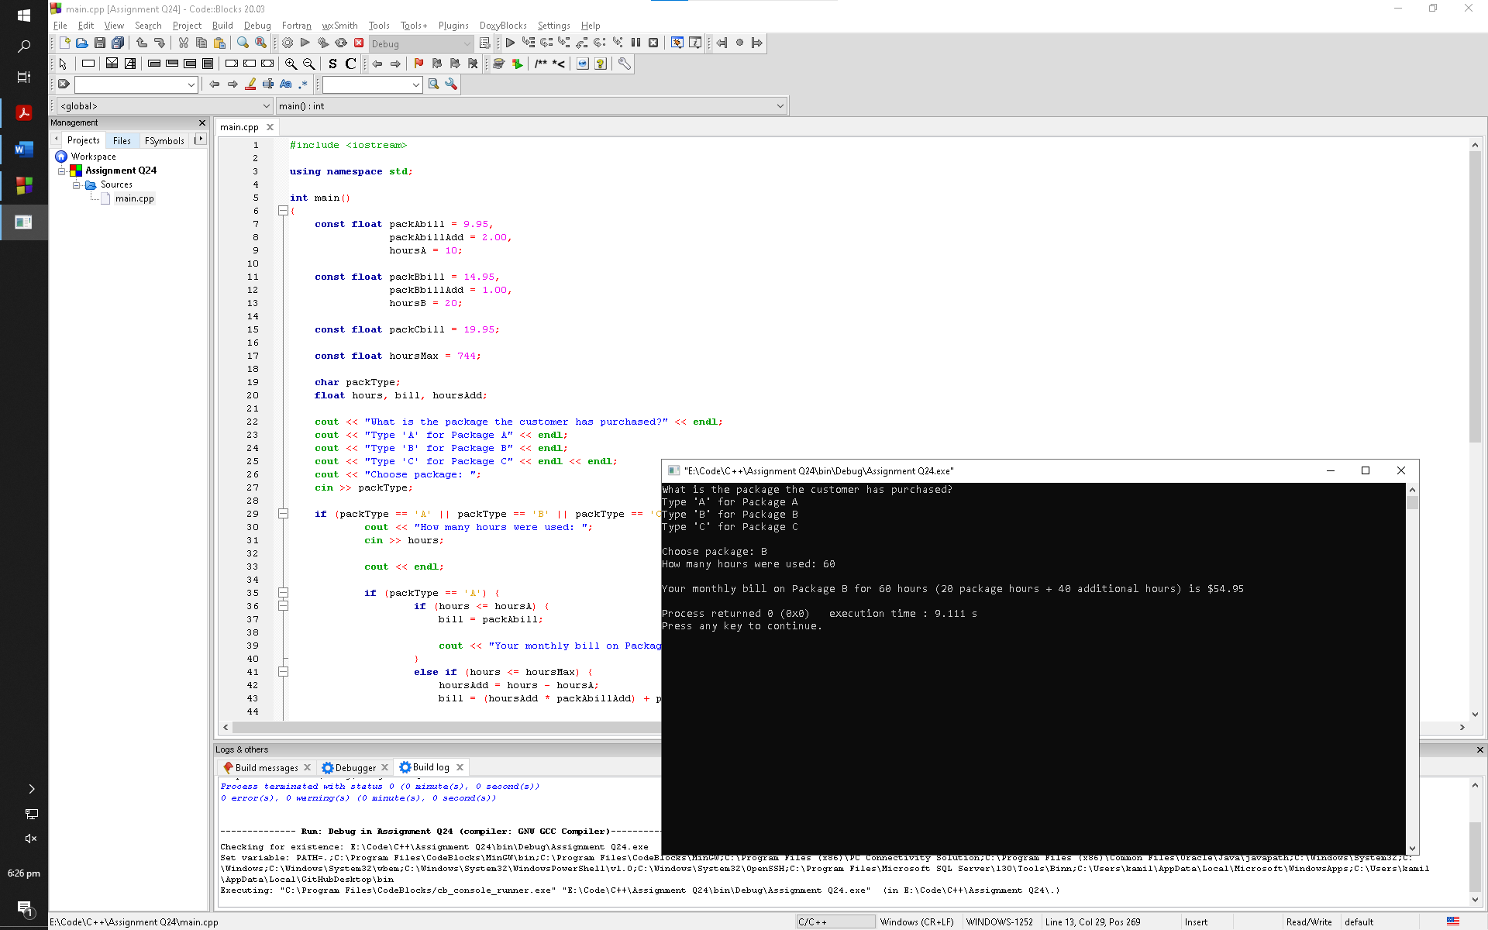

**Q25:**

Months with 30 days have 720 hours, and months with 31 days have 744 hours. February, with 28 days, has 672 hours. Enhance the input validation of the Internet Service

Provider program by asking the user for the month (by name), and validating that the number of hours entered is not more than the maximum for the entire month.

Here is a table of the months, their days, and number of hours in each.

|  |  |  |
| --- | --- | --- |
| **Month** | **Days** | **Hours** |
| January | 31 | 744 |
| February | 28 | 672 |
| March | 31 | 744 |
| April | 30 | 720 |
| May | 31 | 744 |
| June | 30 | 720 |
| July | 31 | 744 |
| August | 31 | 724 |
| September | 30 | 720 |
| October | 31 | 744 |
| November | 30 | 720 |
| December | 31 | 744 |

**Code:**

1. #include <iostream>
3. using namespace std;
5. int main()
6. {
7. const float packAbill = 9.95,
8. packAbillAdd = 2.00,
9. hoursA = 10;
11. const float packBbill = 14.95,
12. packBbillAdd = 1.00,
13. hoursB = 20;
15. const float packCbill = 19.95;
17. char packType;
18. string month;
19. float hoursMax, hours, bill, hoursAdd;
21. cout << "What is the package the customer has purchased?" << endl;
22. cout << "Type 'A' for Package A" << endl;
23. cout << "Type 'B' for Package B" << endl;
24. cout << "Type 'C' for Package C" << endl << endl;
25. cout << "Choose package: ";
26. cin >> packType;
28. if (packType == 'A' || packType == 'B' || packType == 'C') {
29. cout << "Choose a month you want to get bill for: ";
30. cin >> month;
32. if (month == "Jan" || month == "January" ||
33. month == "Mar" || month == "March" ||
34. month == "May" ||
35. month == "Jul" || month == "July" ||
36. month == "Aug" || month == "August" ||
37. month == "Oct" || month == "October" ||
38. month == "Dec" || month == "December") {
40. hoursMax = 744;
41. }
42. else if (month == "Apr" || month == "April" ||
43. month == "Jun" || month == "June" ||
44. month == "Sept" || month == "September" ||
45. month == "Nov" || month == "November") {
47. hoursMax = 720;
48. }
49. else if (month == "Feb" || month == "February") {
51. hoursMax = 672;
52. }
54. cout << "How many hours were used: ";
55. cin >> hours;
57. cout << endl;
59. if (packType == 'A') {
60. if (hours <= hoursA) {
61. bill = packAbill;
63. cout << "Your monthly bill on Package A for " << hours << " hours is $" << bill << endl;
64. }
65. else if (hours <= hoursMax) {
66. hoursAdd = hours - hoursA;
67. bill = (hoursAdd * packAbillAdd) + packAbill;
69. cout << "Your monthly bill on Package A for " << hours << " hours (" << hoursA << " package hours + " << hoursAdd << " additional hours) is $" << bill << endl;
70. }
71. else {
72. cout << "Error, the hours you entered are incorrect" << endl;
73. }
74. }
75. else if (packType == 'B') {
76. if (hours <= hoursB) {
77. bill = packBbill;
79. cout << "Your monthly bill on Package B for " << hours << " hours is $" << bill << endl;
80. }
81. else if (hours <= hoursMax) {
82. hoursAdd = hours - hoursB;
83. bill = (hoursAdd * packBbillAdd) + packBbill;
85. cout << "Your monthly bill on Package B for " << hours << " hours (" << hoursB << " package hours + " << hoursAdd << " additional hours) is $" << bill << endl;
86. }
87. else {
88. cout << "Error, the hours you entered are incorrect" << endl;
89. }
90. }
91. else if (packType == 'C') {
92. if (hours <= hoursMax) {
93. bill = packCbill;
95. cout << "Your monthly bill on Package C for " << hours << " hours is $" << bill << endl;
96. }
97. else {
98. cout << "Error, the hours you entered are incorrect" << endl;
99. }
100. }
101. }
102. else {
103. cout << "Error, the package you entered is incorrect" << endl;
104. }
106. return 0;
107. }

**Output Window:**

